**Computing Project Proposal**

**On**

**Blog Application**

**Name: Arju Dutta**

**NCC ID: 00175070**

**Batch: 22 ‘D’**

**Submitted to: Niman Maharjan**

**Level 5 Diploma in Computing**

**Softwarica College of IT and E-Commerce**

**Submitted 29Th July 2019**

Contents

Abstract 3

Acknowledgement 4

Introduction: 5

1.1 Background of project 5

1.2 Problem statement 5

1.3 Aims and Objective. 5

1.4 Features: 6

2.1 Analysis: 7

2.2 SWOT (strength weakness opportunities threats) 8

2.3 Feasibility study 9

2.4 Requirement Analysis 10

2.5 Moscow prioritization 11

2.6 System requirement specification 12

2.7 NLA (Natural Language Analysis). 13

2.8 Use case Diagram 14

2.9 Class diagram 15

3 Design: 16

Introduction: 16

3.1 Structural design: 16

Class diagram: 16

Association: 17

Generalization: 17

Dependency: 17

Realization: 17

3.3 Behavioral: 19

Activity 19

3.5 Sequence diagram: 20

3.6 Database Design 21

Data dictionary 21

1.Blogger 21

2.Blog 21

3.Blog Entry 21

4. Question 22

5.Comment 22

3.7 ER diagram: 23

Entity relationship modelling: 23

3.8 Architectural Design: 24

3.9 UI design: 25

Paper Prototype: 25

4 Coding: 30

5 Testing: 47

5.1 Blackbox testing 47

5.2 Unit testing: 52

6 Topic 53

6.1 Introduction of project: 53

6.2 Risk management: 53

6.3 Configuration management: 56

6.4 Scheduling: 57

6.5 Future work: 59

6.6 User manual for admin 59

6.7 User manual for user 59

6.8 Limitation: 59

7 Appendix: 60

Conclusion 86

References 87

# Table of figure:

Figure 1:usecase diagram 19

Figure 2:Class diagram 20

Figure 3:class diagram 22

Figure 4:DFD 23

Figure 5:activity diagram 24

Figure 6:sequence diagram 25

Figure 7:ER diagram 28

Figure 8:home page 30

Figure 9:home page button 31

Figure 10:slider blog 31

Figure 11:blog category 32

Figure 12:about page 32

Figure 13:user subscribe 33

Figure 14;view the information 33

Figure 15:category 34

Figure 16:home page 35

Figure 17:homepage code 36

Figure 18:home page code 36

Figure 19:homepage code 37

Figure 20:homepage code 37

Figure 21:admin register 38

Figure 22:login form 39

Figure 23:login register code 39

Figure 24:login register code 40

Figure 25;admin register database 40

Figure 26:admin dashboard 41

Figure 27:admin dashboard code 41

Figure 28:add category 42

Figure 29:table view 42

Figure 30:content database 43

Figure 31:blog category 43

Figure 32:about homepage 44

Figure 33:about home page code 44

Figure 34:about homepage code 45

Figure 35:about homepage code 45

Figure 36:blog post homepage 46

Figure 37:blog post homepage code 46

Figure 38:blog post homepage code 47

Figure 39:blog post homepage code 47

Figure 40:blog post homepage code 48

Figure 41:blog post homepage code 48

Figure 42:blog post homepage code 49

Figure 43:blog post homepage code 49

Figure 44:blog post homepage code 50

Figure 45:blog post homepage code 50

Figure 46:contact code 51

Figure 47;contact code 51

Figure 48:blog insert 52

Figure 49:blog database 53

Figure 50:blog category 53

Figure 51:blog category database 54

Figure 52:ogin form 54

Figure 53:login form database 55

Figure 54:admin register form 55

Figure 55:editor choice details 56

Figure 56:editor choice details database 56

Figure 57:link details 57

Figure 58:configuration management 61

Figure 59:tree 61

Figure 60:day estimated 62

Figure 61:Gannt chart 63

# Abstract

Before I started project, this project was planned by predicting all time line in Gantt chart. All documentation was made to create an application. In the first phase of analysis, all data and information has been gathered to know the problem that is exist in Nepal. All the need was easy for customer to park their vehicle in crowded area, school and colleges etc. this process ran through feasibility study of the project through current situation of market. All the requirement has meet Moscow prioritization for this parking booking system to be developed. Then I use case diagram which describe the relation between user and admin. Many more like natural language analysis has been figured out to draw a class diagram for this project this uses static model for the documentation. Then further I started design phase where I have use dynamic model for this project which is final class diagram, sequence diagram, data flow diagram, entity relationship diagram, data dictionary and other. User interface design was designed and then and coding was started. All the project in tested by black box testing.

For this blogging application to design use case, dataflow diagram I have used star UML and to design entity relationship I have used visual paradigm which is best software for designing I have found on the internet. Php, bootstrap, CSS, jQuery, JavaScript, html is used to design the coding. And MYSQL database management system is used to implement the coding.

# Acknowledgement

I would like to give respect to everyone supporting me throughout this computing project. I am glad to thank for the helpful critics and best advice to the issue that I was facing in this blogging application. I express my warm thanks and respect for module leader/ guider/subject teacher Mr. Niman Maharjan for supporting me and guiding me in every step of documentation and rising issues to solution. I feel great to extend to my friends for encouragement and advice to research on project for my project on different source.

# Introduction:

This project is about sharing the view of different individual on the webpage. Todays world is totally based upon information and data which is the most powerful tools in this generation. Technology is changing in our day by day to provide that information of all the articles, latest technology I have designed this web application using php and MySQL.

# 1.1 Background of project

Web based blog application is about where you can share the latest information, blog of entrepreneur, business ideas over the internet. We will also provide the upcoming application, their features and many more other data in this in this web-based application.

By, registering and login into your personal account you can also share your information over the internet so that other people may also know what is going around the world. Those who input the wrong information the account will get blocked.

User interface is designed very well so end user doesn’t have to find any trouble to use this application. I have used php and MySQLi to design this application.

# 1.2 Problem statement

As you can see many fake information is getting viral nowadays in internet through various social media app. Sometimes conflict is creating through that information which is totally hampering the image of an organization individual and many more. There is high chance of getting unauthorized post. Business detail and latest information technology can get hamper or fake.

# 1.3 Aims and Objective.

The main purpose about this system is to share your opinion, upcoming new gadgets in the market and its suitable and genuine features. Beside this we can also increase the communication skill between the individual by interacting by getting latest information.

The main objectives for this project is to handles all the latest information related to particular events. It helps to protect all the related data and information of the users. It will reduce the paper work because every information is digitalized in our web page. Through this we can even get friendly with the modern world which is all based upon technology.

# 1.4 Features:

* Update your information
* Admin Can login your personal account
* People can get latest upcoming information
* They can read various article in this webpage
* You won’t get any wrong information in this blogging application.
* Admin can create update and delete the post.
* Admin can ban the unauthorized post.
* Admin can secure the private post.

# 2.1 Analysis:

Analysis is a subsequent which makes application simple to analyze. It helps to confirm the software without any problem face during the starting phase of project. Analysis helps to create best software by implementing the user requirement within the fix budget.

Requirement analysis is the systematic way of software development. It helps to gather all information or function while creating the project. I have used waterfall model which is traditional method for developing software. Analysis is containing of static and dynamic model. We use various technique for analyzing the project they are

* Feasibility study which will includes
* Schedule feasibility
* Economic feasibility
* Legal feasibility
* Technical feasibility
* Operational feasibility
* System analysis which will include
* Functional requirement
* Non- functional requirement
* Moscow prioritization
* System requirement specification
* Use case
* Class diagram
* NLA (natural language analysis)

## 2.2 SWOT (strength weakness opportunities threats)

For this blogging application I have used SWOT analysis to analyze this project to check what are the strength, weakness, opportunity and threat of the project. After finding out what are weakness it become my opportunity and I have to convert it into strength.



* Strength: the strength of this project will provide all the latest and genuine information to the users. It is the internal purpose for this project. There must be high security in application in which user can feel secure while uploading their information. Strength is essential phase in SWOT.
* Weakness: weakness is the problem of the blogging application which we can easily change into strength. There can be information leakage while uploading the user information in blog application. In every project weakness is the basic components where it defects the project in minor ways and cannot satisfy the user requirement.
* Opportunity: in this methodology we I identify all the upcoming or given opportunity in the system or an organization. We can provide different facilities to the user while uploading their personal information in our application. This application is for the external purpose in our business premises.
* Threat: threat is the upcoming problem in the system which will effective in the future. And to rid off that problem to have to make risk management. Developments in technology may change this project beyond our ability to adapt. A small change in the focus of a large competitor might wipe out any market position we achieve.

# 2.3 Feasibility study

It is the stage where project is validated whether system in beneficial for the company or not. Feasibility studies evaluates proposed project whether it is technically feasible. It always conducts large sums in the stake in which it can be benefit to analysis the project. The types of feasibility study are as follow:

1. economic feasibility: our organization has sufficient amount of income source so there is no any problem in cost. So, our this is feasible it doesn’t extend the estimated budget for this project. Analysis of a project’s cost and revenues to determine whether or not it is logical and possible to complete.
2. Schedule feasibility: the process accessing the degree to which the potential time frame and completion dates for all major activities within a project meet organizational deadlines and constraints for affecting change. Feasibility study is an assessment of the practicality of a proposed project or system.
3. Legal feasibility: it is the study to know if the proposed project confirms the legal and ethical requirements to avoid, to the extent possible, the major problems in the project’s development and implementation, specifying the requirements that nee to be considered at subsequent stages of the PPP process.
4. Technical feasibility: It’s the study of the project in terms of input, processes, output, fields, program and procedures. It is a very effective tool for long term planning and trouble shooting. The technical feasibility study should most essentially support the financial information of an organization.
5. Operational feasibility: It refers to the measure of solving problems with the help of a new proposed system. It helps in taking advantage of the opportunities and fulfills the requirement as identified during the development of the project.

## 2.4 Requirement Analysis

1. Functional Requirements

It is the behavior of the system. It describes how system will perform. This is provide for the users to understand the system. It includes list of some features and show how does it perform to the system. The functional requirement of this system are given below:

|  |  |  |  |  |
| --- | --- | --- | --- | --- |
| ID | TITLE | DESCRIPTION | RATIONAL | DEPENDENCY |
| 1. | REGISTER | USER should be register into the system | It should be done to create personal account | N/A |
| 2. | Login | User should login into their account | To should allow user for access the system | 1 |
| 3. | Update information | User should upload their information | To share the information to the follower | 2 |
| 4. | Follow page | User should allow to follow the send | To is to view the view In the dashboard | 2 |
| 5. | Chat | User can chat | To increase the communication | 2 |

1. Non-functional requirement

It is the support of the system features system indirectly. It identifies how the system work. It shows the quality of the system. The non-functional requirement for this system is given below

|  |  |  |  |
| --- | --- | --- | --- |
| Id | Title | Description | Dependency |
| 1. | People can upload file and picture | They can upload or may not upload | 2 |
| 2 | Like and comment | People may like and comment in the uploading information | 3 |
| 3 | Follow and unfollow | People can follow and unfollow pages | 3 |
| 4 | Upload information | User may or may not upload the information | 4 |

## 2.5 Moscow prioritization

It is also known as Moscow method; Moscow analysis and it is a popular prioritization technique for the requirements. The method is commonly used to help key stakeholders understand the significance of initiatives in a specific release. The acronym, Moscow, stands for 4 different categories of initiatives: must-haves, should-haves, could-haves, and will not have at this time. Sometimes, the “W” in Moscow is used to stand for “wish” instead of “will not have right now.”

Moscow prioritization of functional requirement:

|  |  |  |
| --- | --- | --- |
| Id | Functional requirement | Moscow |
| 1 | Register | Must have |
| 2 | Update information | Should have |
| 3 | Follow page | Could have |
| 4 | chat | Must have |

Moscow prioritization for nonfunctional requirement

|  |  |  |
| --- | --- | --- |
| Id | Non- functional requirement | Moscow |
| 1 | People can upload file and photos | Must have |
| 2 | Like and comment | Should have |
| 3 | Follow and unfollow | Should have |
| 4 | Upload information | Should have |

# 2.6 System requirement specification

it deals with the system behavior and the features of the set of documentation in software application. Motivation should be provided opportunity and a combination of problems that can managed in new system. It helps to identify constraints for the project and helps to consider the interface of requirements. It should be functional capabilities where project will be quality product. Performances level of the system should be managed in systematic way.

* I have use case which have interaction with the user while developing software
* It depends upon system service where expected user can mention idea and view
* Nonfunctional is required for the system properties and constraints

System requirement

|  |  |
| --- | --- |
| Operating system | Windows 7, 8 10 |
| Processor | Intel core 7th generation or 8th generation |
| System type | 32 or 64 bit |
| Ram | 4 or 8gb ram |
| Programming language | Php, html, CSS, java script |
| Database | My sql server |

## 2.7 NLA (Natural Language Analysis).

Blog application is a regularly updated website or web page, typically one run by an individual or small group, that is written in an informal or conversational style. A blog is an online diary or journal located on a website. The content of a blog typically includes text, pictures, videos, animated GIFs and even scans from old physical offline diaries or journals and other hard copy documents. Since a blog can exist merely for personal use, sharing information with an exclusive group or to engage the public, a blog owner can set their blog for private or public access.

This website has different function which can deal with the user requirements. Different large organization are allowed to upload their business transaction. In this application user are allowed to upload their information by creating gifs, text, videos, picture etc.

|  |  |
| --- | --- |
| Noun | verb |
| User | upload |
| Admin | search |
| Blog | write |
| picture | manage |
| video | set |

Description of nouns.

|  |  |  |  |
| --- | --- | --- | --- |
| S.N. | Nouns | Yes/no | justification |
| 1 | Blog | Yes | Blog is selected as class of my project because it is main aspects of the system. |
| 2 | User | Yes | In order to operate into my system, it is essential aspect for my project. |
| 3 | Admin | Yes | It is very important aspect of my system in order to control whole system. |

## 2.8 Use case Diagram

Use case helps to develop analysis system requirement. User and system interact with the specific environment. It’s the graphic depiction of the interactions among the elements of a system. it’s a methodology that is used in system analysis to identify, clarify, and organize system requirements. the main specific purpose is to gather system requirements and actors.

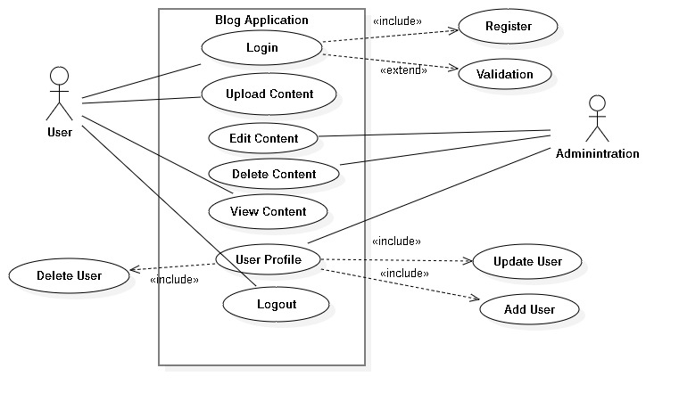

Figure 1:usecase diagram

## 2.9 Class diagram

It’s an illustration of the relations and source code dependences among the classes in the UML (Unified Modeling language). In this context, a class defines the methods and variables in an object. Class diagram is a specific entity in a program or the unit of code representing that entity. It’s a static structure diagram that describes the structure of a system by showing the system’s classes, their attributes, operation and the relationships among objects.

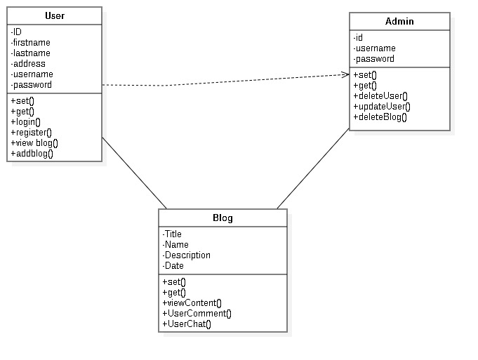

Figure 2:Class diagram

# 3 Design:

## Introduction:

A design is a plan or specification activity done to complete the final product of prototype. There is a process of developing a verb expresses in a design. Design help us to fulfill the project in the systematic way to maintain the form of the prototype. The main aim of designing is to construct of a project or object by coding and graphic design. The main examples of design are to maintain business processes, maintain circuit diagram in systematic way.

The main types of design are conceptual design and technical design are summarized below:

3.1 Structural design: The design consists of 3 diagrams listed below:

* Class diagram
* Object diagram
* Data flow diagram

It is the method of investigating of the constable, power and inflexibility of the structures. It has the basic concept objective in structure analysis and design is to maintain a structure capacity of resetting all functional loads without fail during its future life.

Class diagram: It is a static view of an application. It helps to describe the types of objective system and also deals with different types of relationships that only exist beyond them. It can also be run by modeling method with most of all object oriented methods.

* Class
* Attributes
* Operations
* Relationship
* Constraint rules and notes.

### Association:

* It helps to specifying the object of single class are connected to object of the another class. For eg: an member working for the company.
* It also has directed association and multiplicity association.

### Generalization:

* It helps to specifies the object of the analyzed class one substitutable for the general class.
* It is a kind of relationship.

### Dependency:

* It depends upon the whole life time

### Realization:

* One class always implements a behaviors specified by different class
* It can also be maintain by many classes.



Figure 3:class diagram

3.2 DFD (data flow diagram)

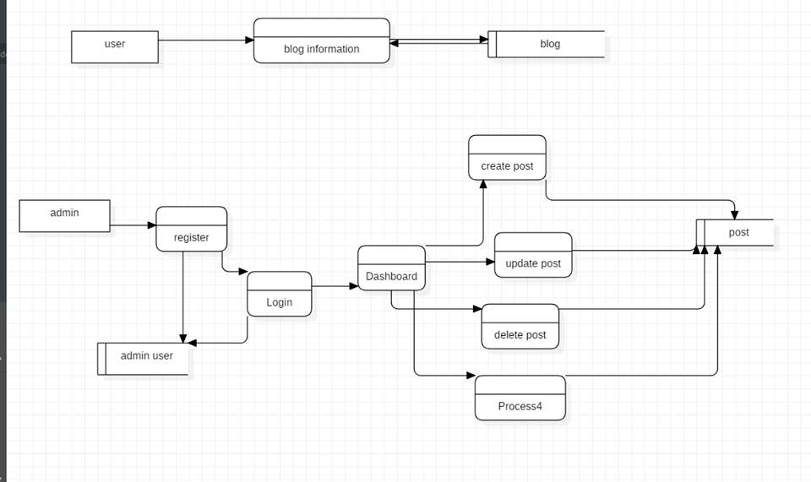

Figure 4:DFD

DFD

It is used to represent graphically of the flow of data in a business information system. It describe the processes that are include in a system to a transfer data from the input of the file storage.It can be classfied into logical and physical.

* External entity: it can represent a person, a machine and an organization which flow into the system.
* Process: it is inolved in a system to transfer data from the given input to the large file storage and report the various generation.
* Dataflow: it is used for graphical represent the flow of the data in a business information system.
* Data store: they are repositories of the system in the data and it is sometimes also referred to as files.

# 3.3 Behavioral:

Activity Diagram: the first phase state before an activity take part in depicted using the initial state.

# Activity

* It shows the flow of activity to activity in advances state chart diagram within the classified system.
* It has the dynamic view in the system which addresses activity diagram.
* It has very important phase for modelling the function of a system.

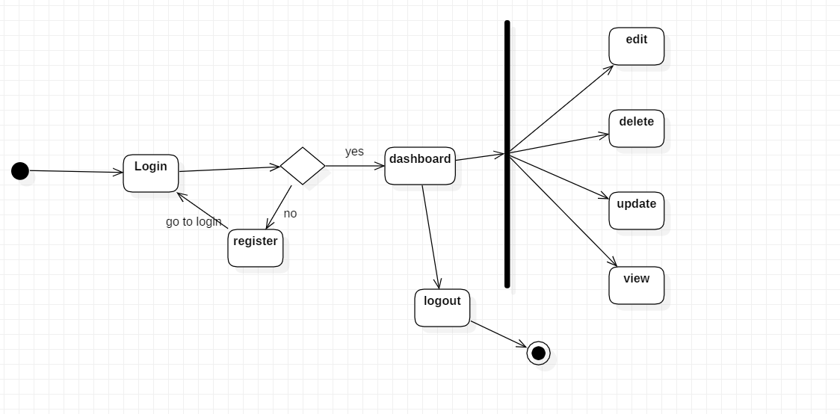

Figure 5:activity diagram

# 3.5 Sequence diagram:

Sequence diagram is the interaction between objects in a sequential order. And many orders take place during the phase of interaction. To refer sequence diagram, we have to use terms event diagram or event scenarios. The sequence diagram deals with how and what order the objects in a system function.

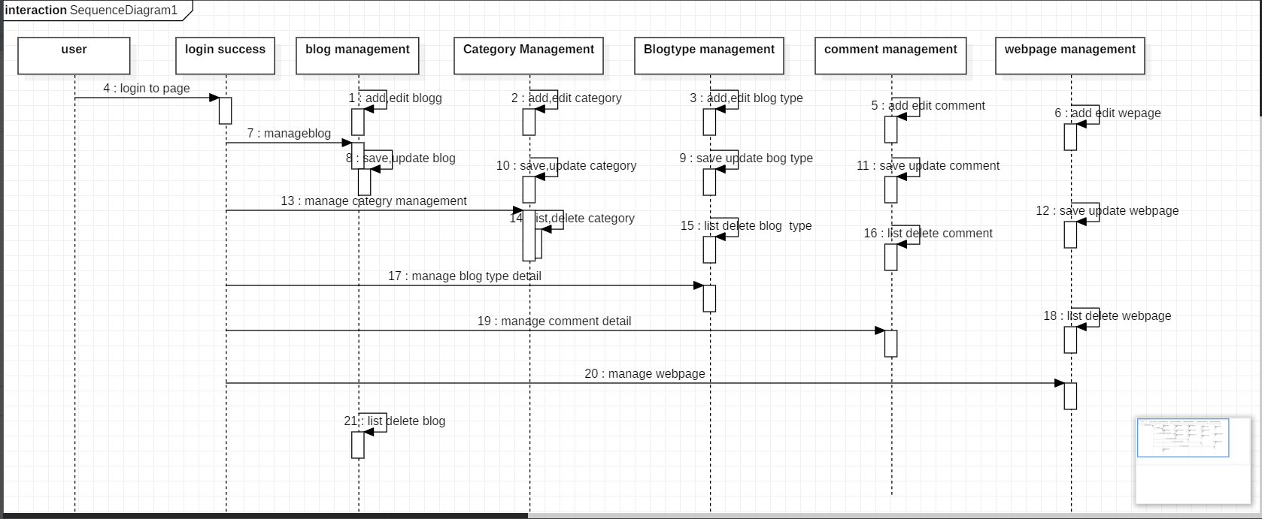

Figure 6:sequence diagram

# 3.6 Database Design

The organization which keeps record according to a database model. It helps to determines where data must be stored and how the data elements interrelate. Data can be fit in the database model when the process is beginning. Database design are directly related or involves in identifying and classifying data. It can help to reduce duplicate value.

## Data dictionary

* It helps to keep all official details that contains of data flow process and data store.
* It has got all set of explanations of all data flow diagram element.
* It consist of owner table and columns of table related to each other.

The terms that define data dictionary are:

* Data structure: it is used to designed to organize data to suit a specific purpose.
* Data elements: it is the specific set of values or range of values which is the part of its own definition.
* Data flows and data stores: It contains data inputs and outputs where data are been store, and the different subprocesses the data flows through.

### 1.Blogger

|  |  |  |  |
| --- | --- | --- | --- |
| Name | Datatype | Constraints | Nullable |
| userid | Int | Primary key unique | No |
| email | Varchar(225) |  | No |
| password | Varchar(225) |  | No |

### 2.Blog

|  |  |  |  |
| --- | --- | --- | --- |
| Name | Datatype | Constraints | Nullable |
| Bloggeruserid | Int(10) |  |  |
| Blogid | Int(10) | Primary key unique | No |
| title | Varchar(225) |  | No |
| creationdate | date |  | No |

### 3.Blog Entry

|  |  |  |  |
| --- | --- | --- | --- |
| Name | Datatype | Constraints | Nullable |
| Blogblogid | Int(10) |  |  |
| entryid | Int(10) | Primary key unique | No |
| text | Varchar(225) |  | No |
| Subject_title | Varchar(225) |  | No |
| postby | Varchar(225) |  | No |
| creationdate | Int(10) |  | No |
| Commentcommentid | Int(10) |  |  |

### 4. Question

|  |  |  |  |
| --- | --- | --- | --- |
| Name | Datatype | Constraints | Nullable |
| Blogblogid | Int(10) |  |  |
| questionid | Int(10) | Primary key unique | No |
| text | Varchar(225) |  | No |
| answer | Varchar(225) |  | No |

### 5.Comment

|  |  |  |  |
| --- | --- | --- | --- |
| Name | Datatype | Constraints | Nullable |
| commentid | Int(10) | Primary key unique |  |
| Comment_type | Varchar(225) | Primary key unique | No |
| catgorised | Varchar(225) |  | No |
| text | Varchar(225) |  | No |

# 3.7 ER diagram:

Er is a type of structural diagram that is used in database design. It has various kind of symbols and connectors the deals with two essential information. The inter-relationships among these entities and major entities within the system scope.

# Entity relationship modelling:

* It has got many assets attributes that describe them.
* It has been created to maintain those entities, attributes and relationship graphically is ERD.
* It has got various way of defining a business process.

Components in database design described below:

* Entity: It is an event, place or organization and people.
* Attributes: the main function is to describe entity.
* Relationships: It describe the relation between entities.

There are 3 types of modelled relationships are listed below:

• One to one relationship,

• One to many relationship,

• Many to many relationship,

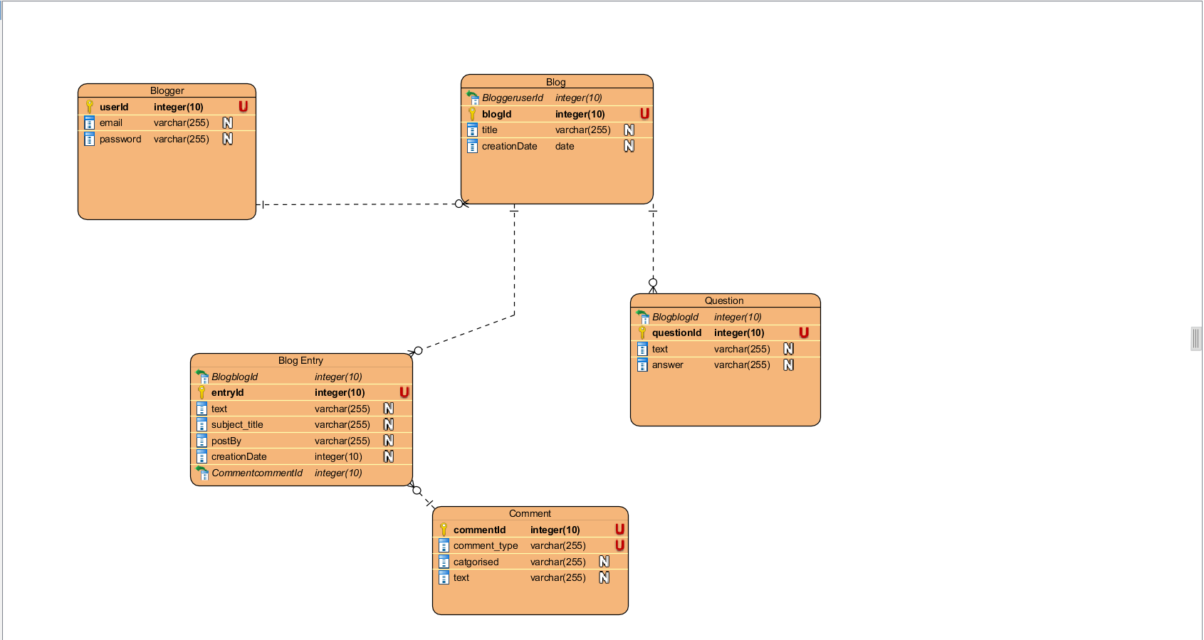

Figure 7:ER diagram

# 3.8 Architectural Design:

Architectural design are always used to represent the basic design of the software. It is structure of data that are made to construct a computer based system.

* It has been classified as system engineer are model of required context.
* It interacts with external entities in the context diagram model.

For this computing project I have used MVC design for the system.

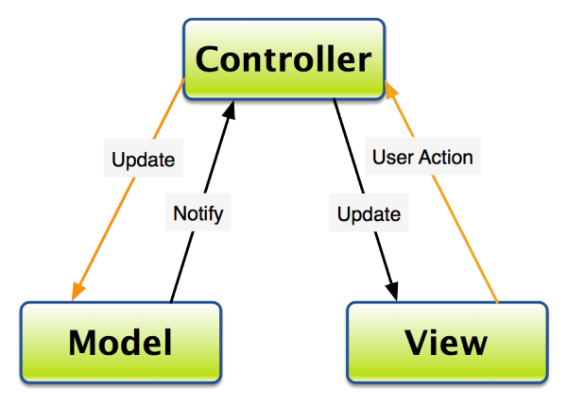

# 3.9 UI design:

* UI is the access point where user directly interacts with designs.
* (GIU)s control panel helps to design and interface involves in oral auditory interaction.
* Gesture based interface is the user distracting with 3d design i.e. bodily motions.
* It is the craft that engage building an important phase of user skill; there is chance of deign getting usability or likeability.

## Paper Prototype:

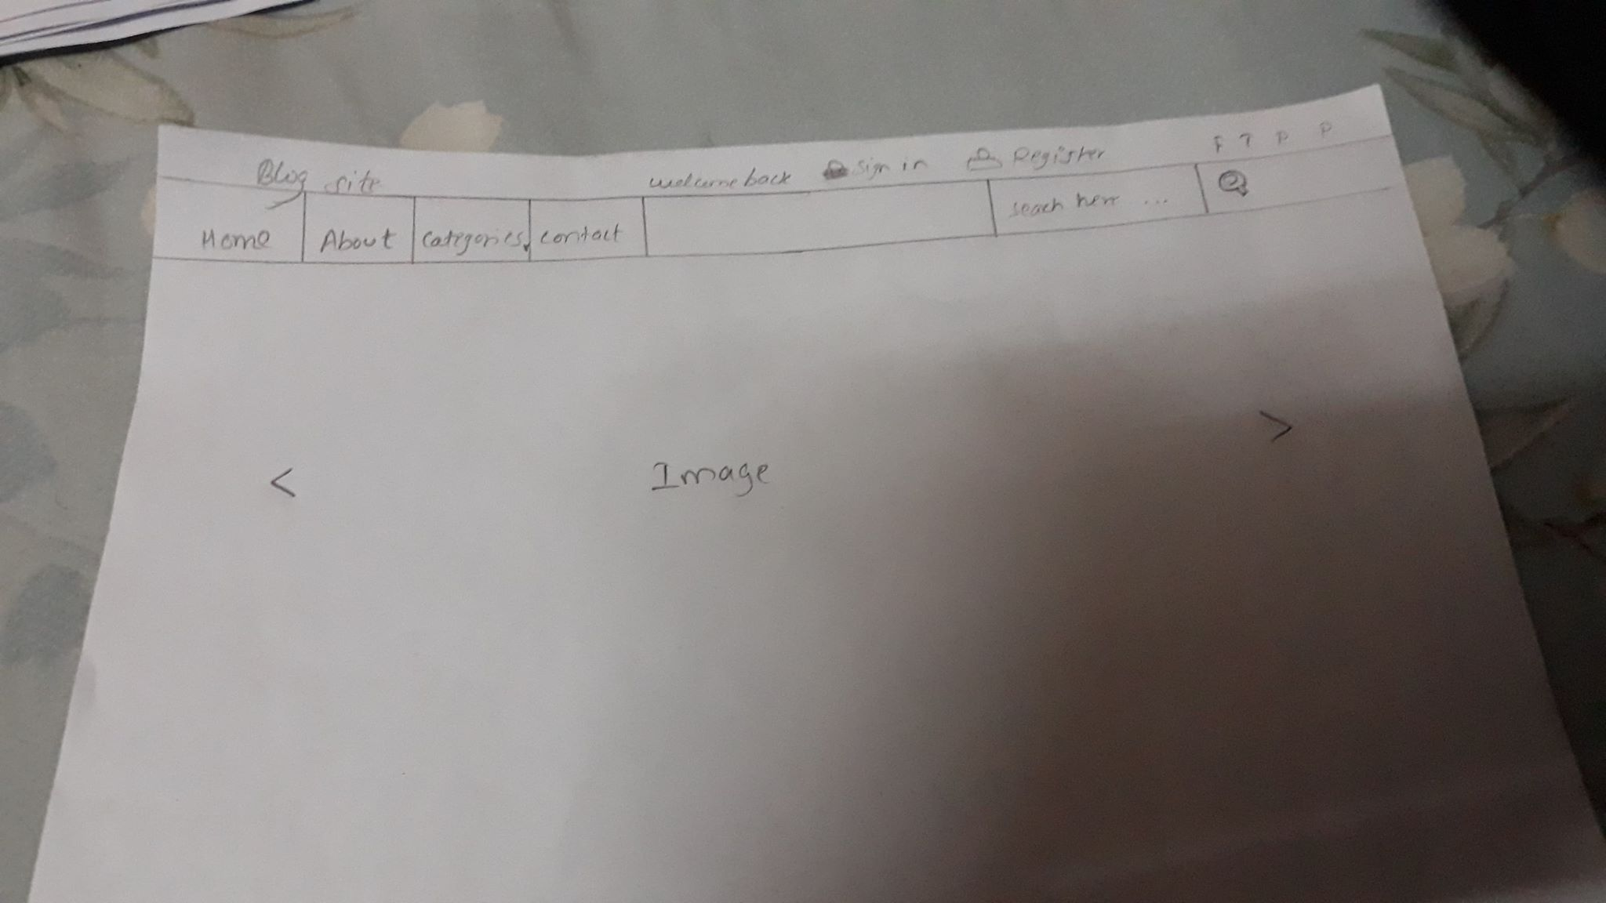

Figure 8:home page

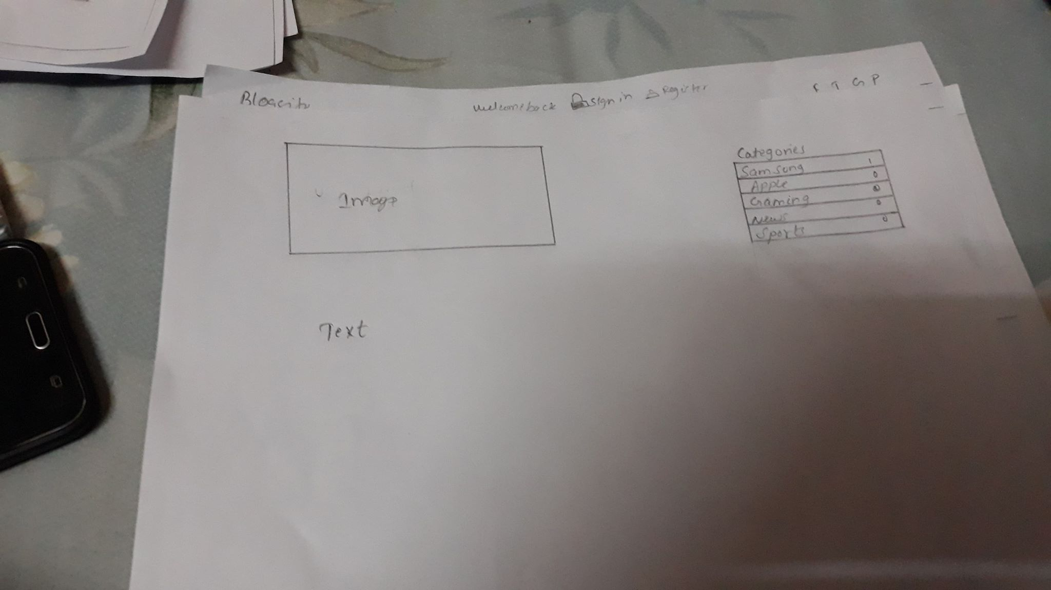

Figure 9:home page button

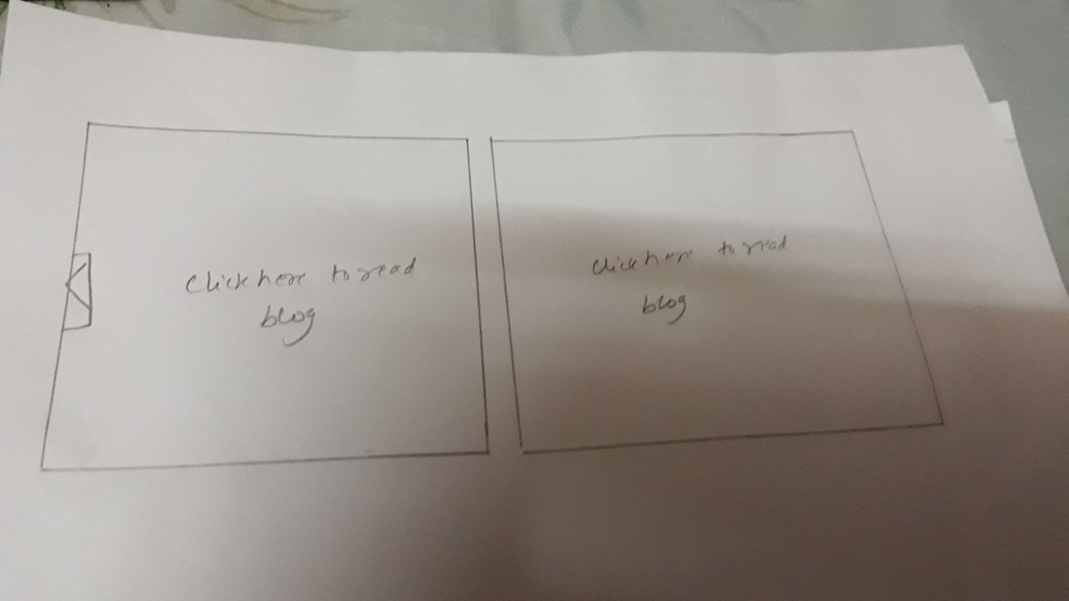

Figure 10:slider blog

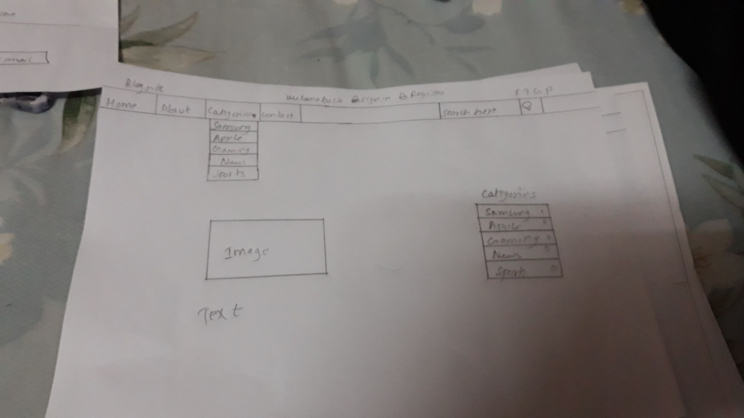

Figure 11:blog category

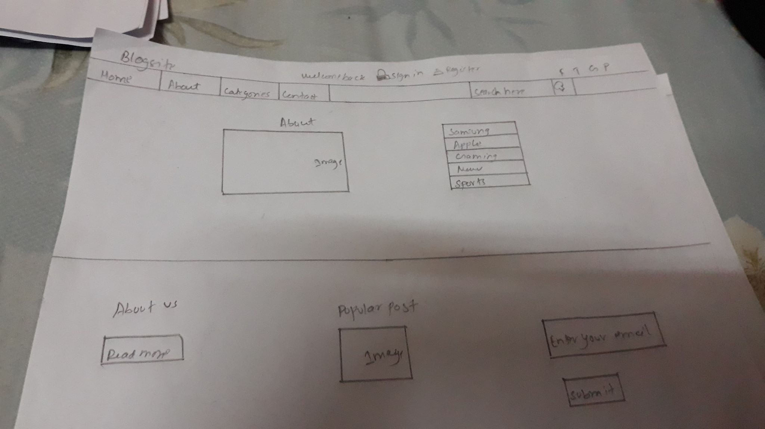

Figure 12:about page

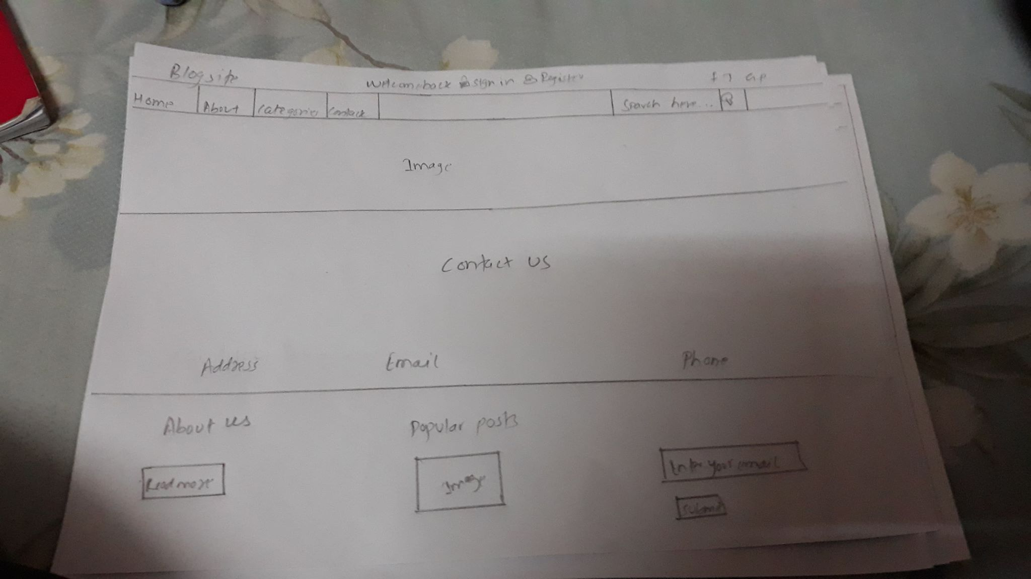

Figure 13:user subscribe

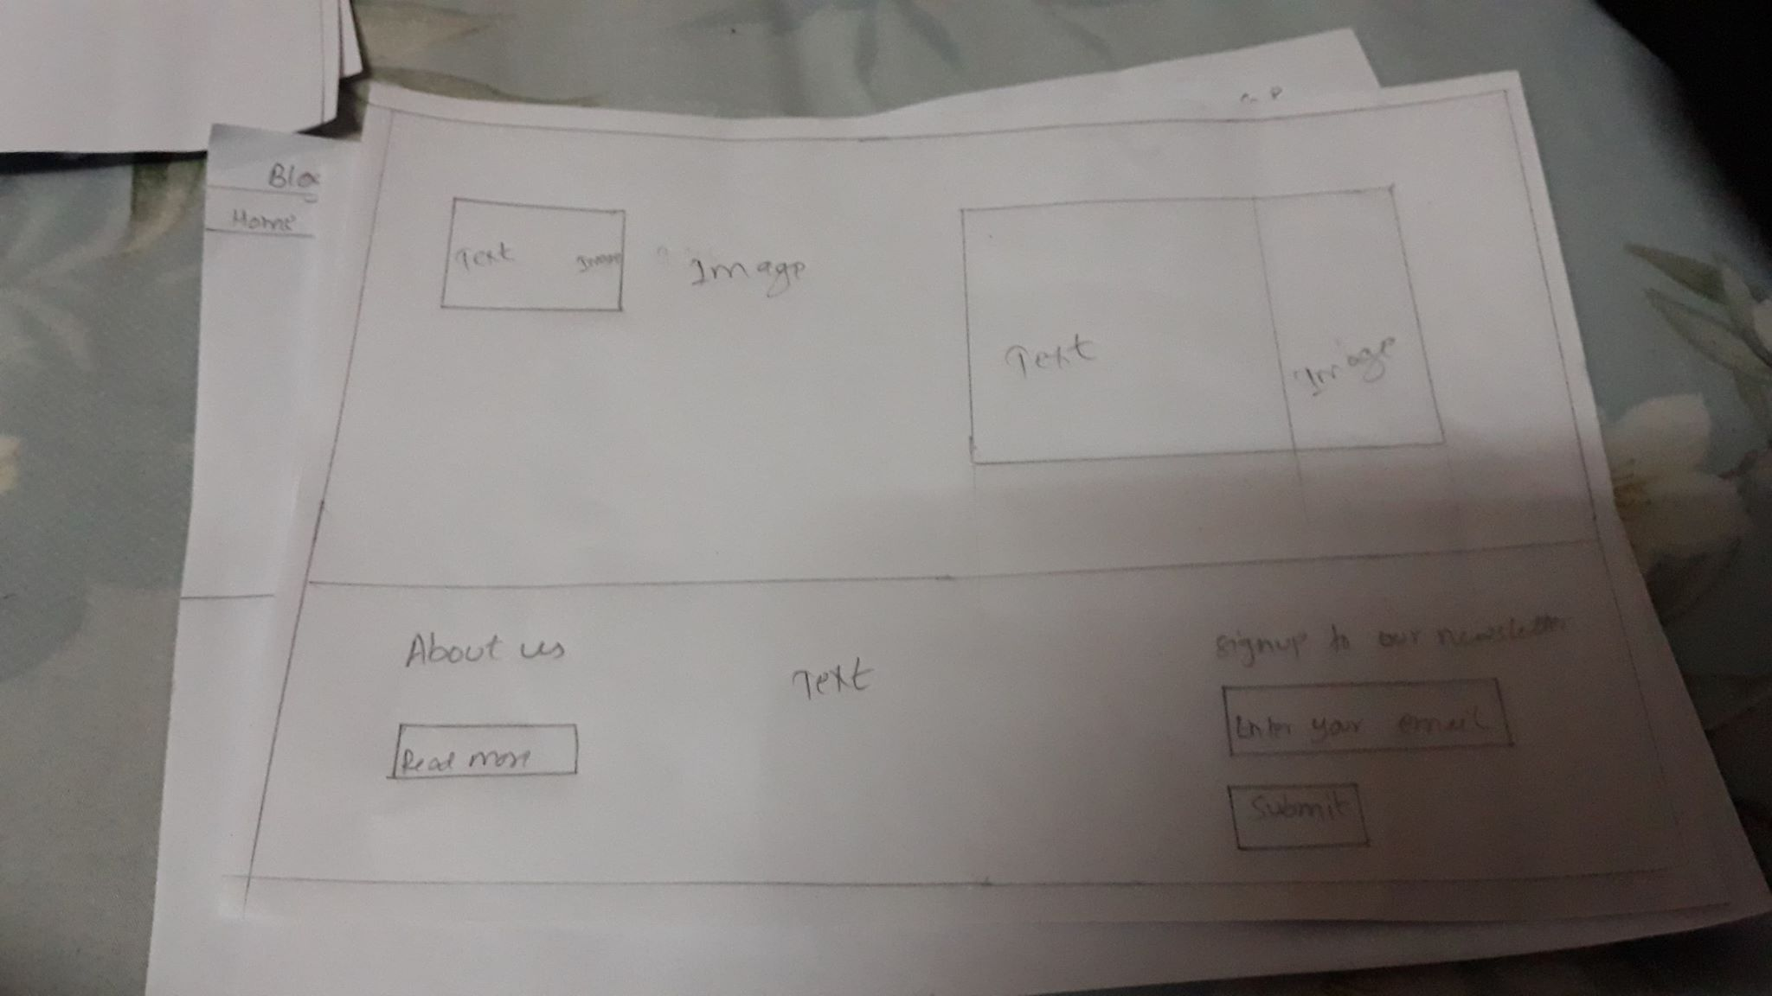

Figure 14;view the information

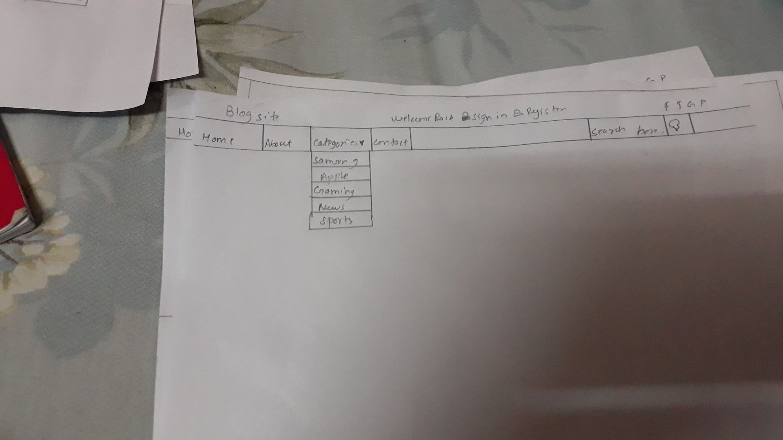

Figure 15:category

# 4 Coding:

In this phase I have created blog application with the help of core php, java script, j query and CSS. this coding phase has various kind of code for the completion of this project. I have used many types of CSS and java script for the best design of this project. With the help of this coding user can easily manage their updated post. With the help of analysis and design I had implement the coding according to its design. Class diagram will help on to implement to coding while making classes. Design is the phase where we analyze the design for further coding. Before coding we write it’s features in the analysis where we overall analyze its design and describe how to going to make its features.



Figure 16:home page

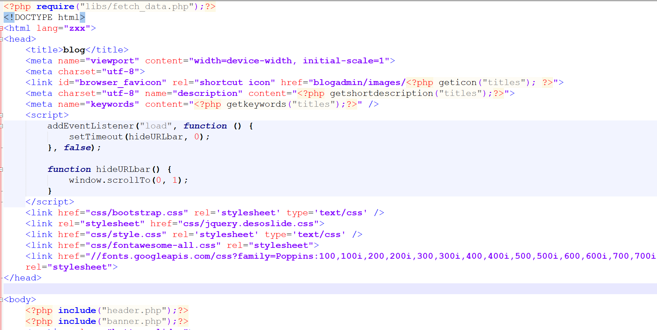

Figure 17:homepage code

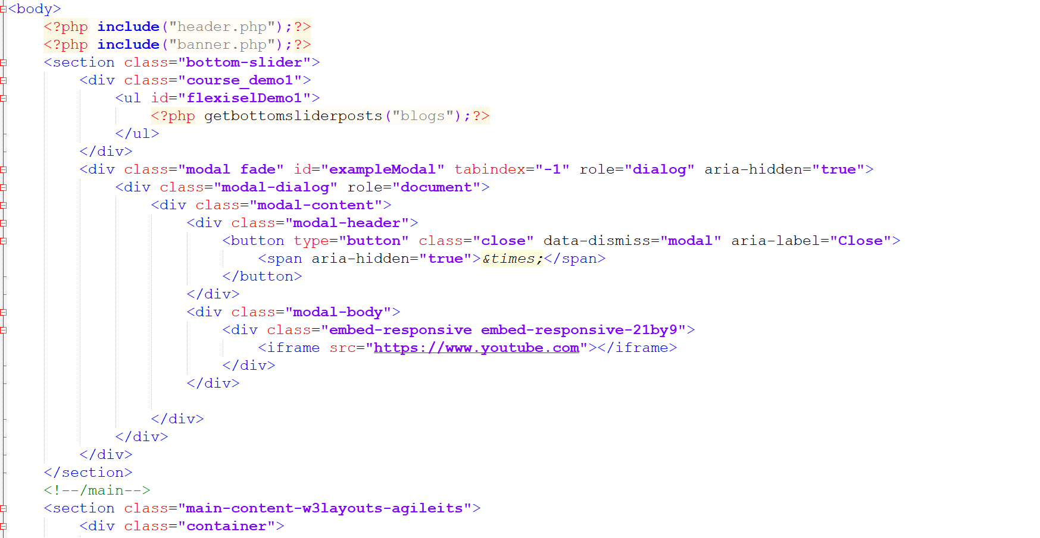

Figure 18:home page code

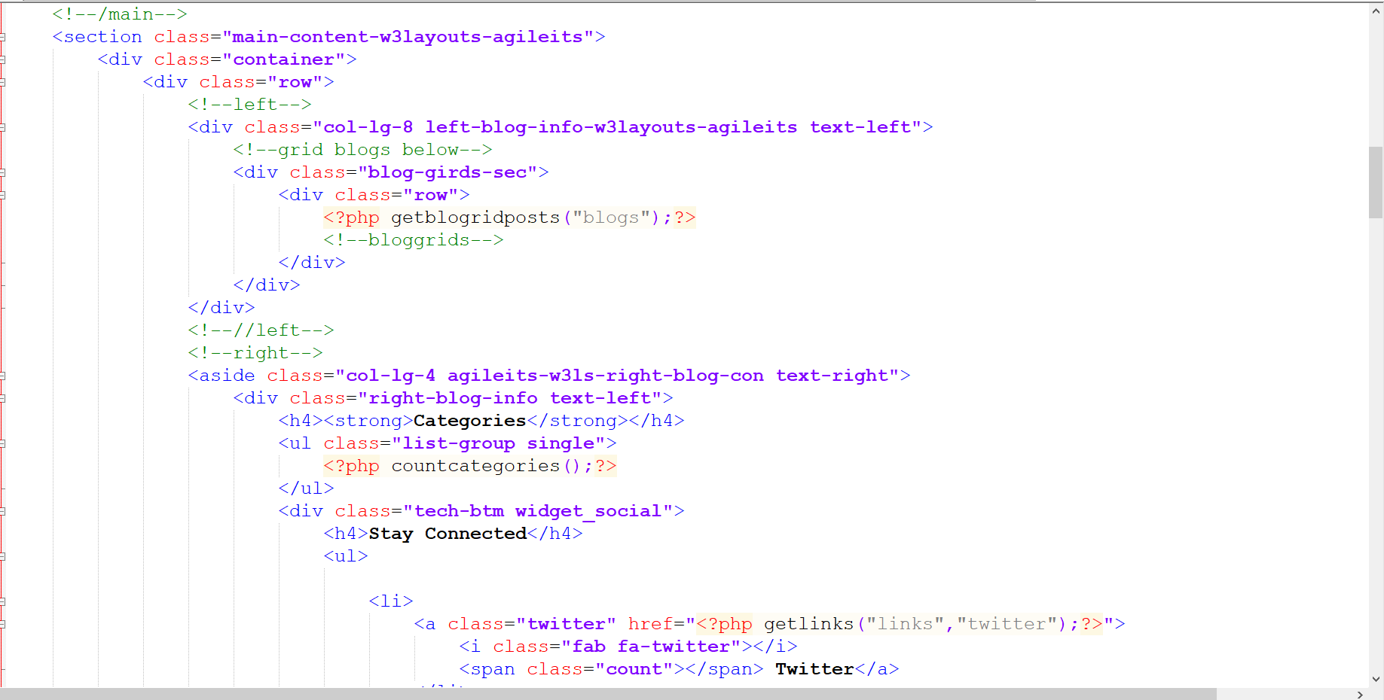

Figure 19:homepage code

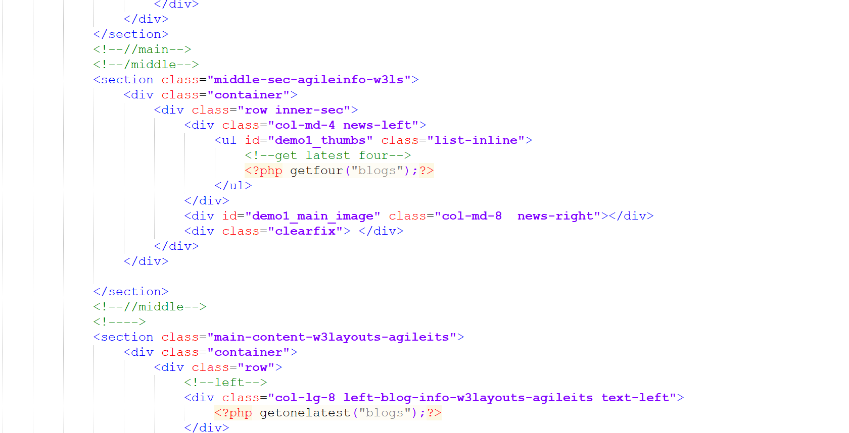

Figure 20:homepage code

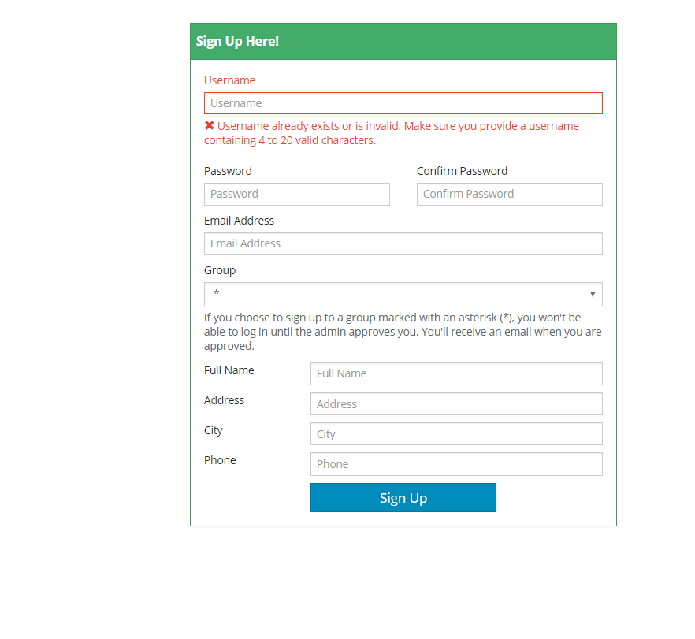

Figure 21:admin register

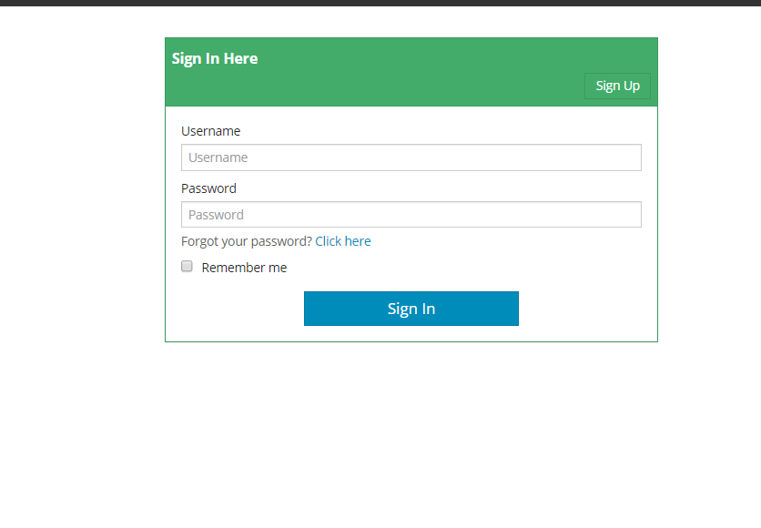

Figure 22:login form

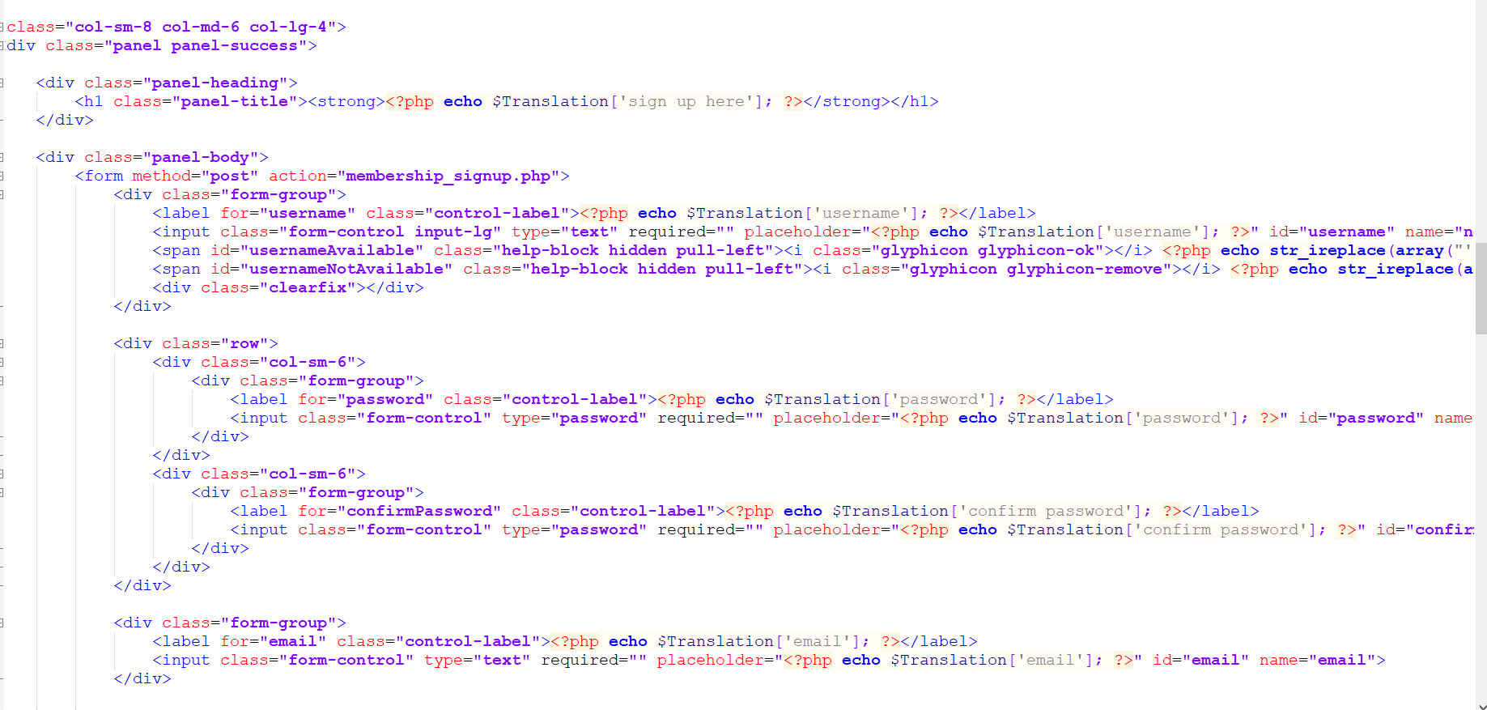

Figure 23:login register code

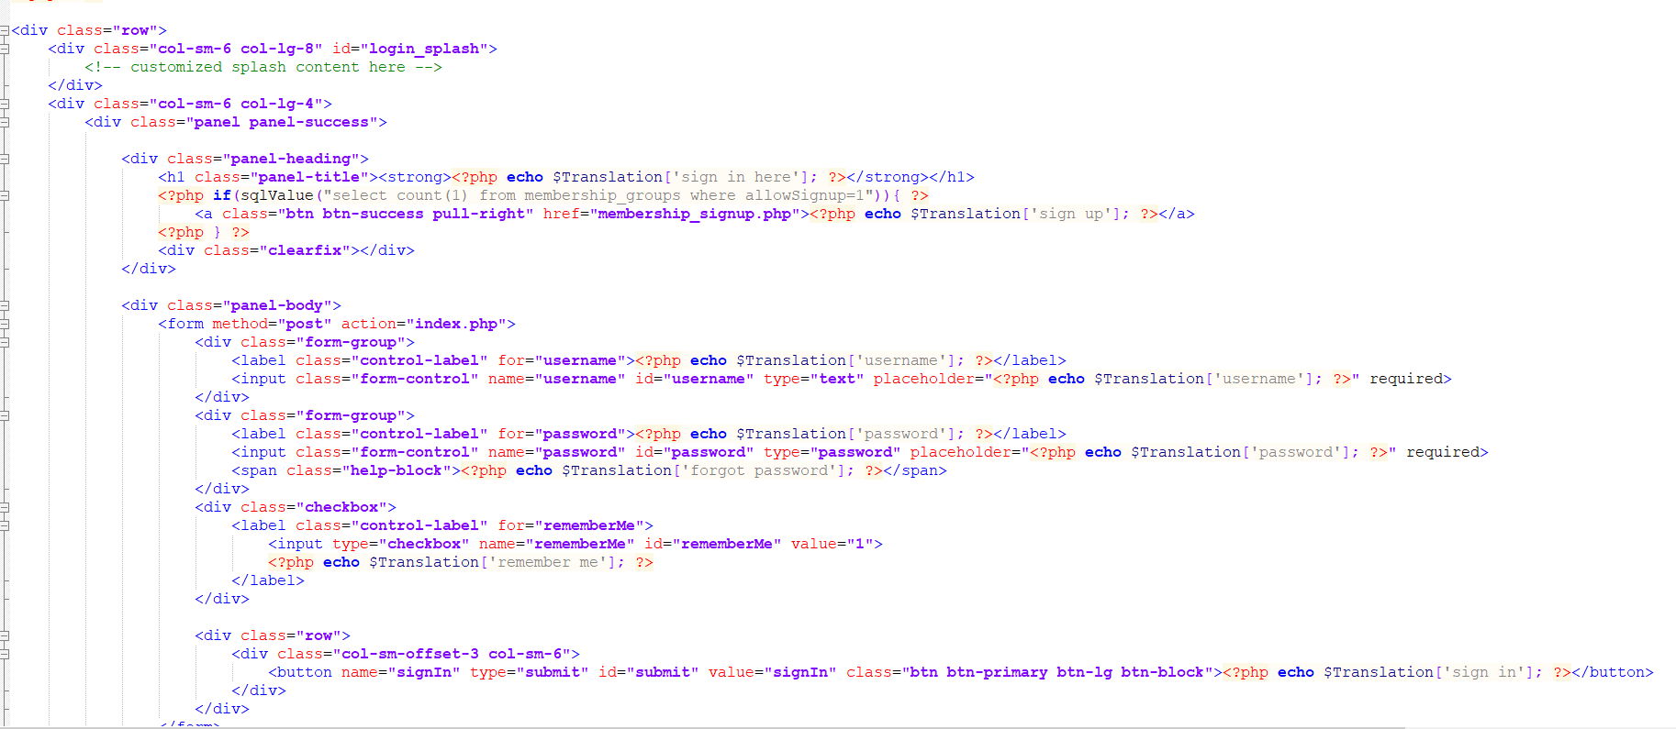

Figure 24:login register code

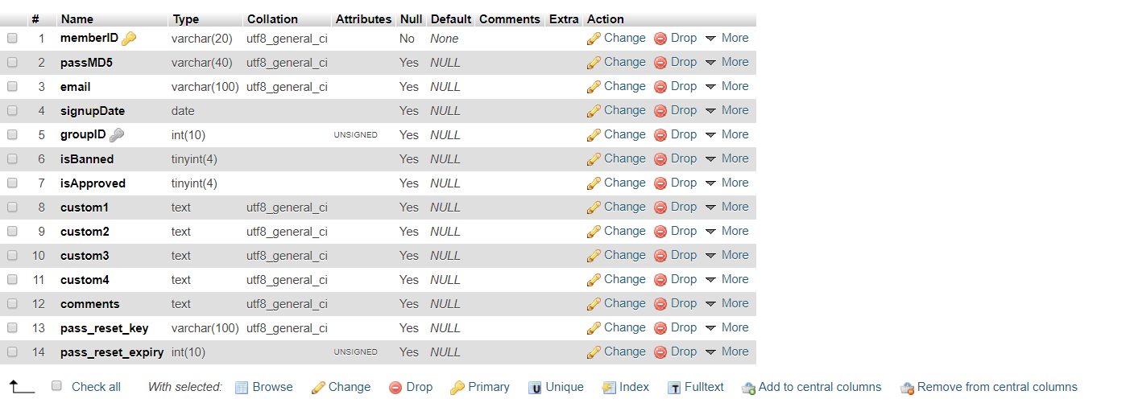

Figure 25;admin register database

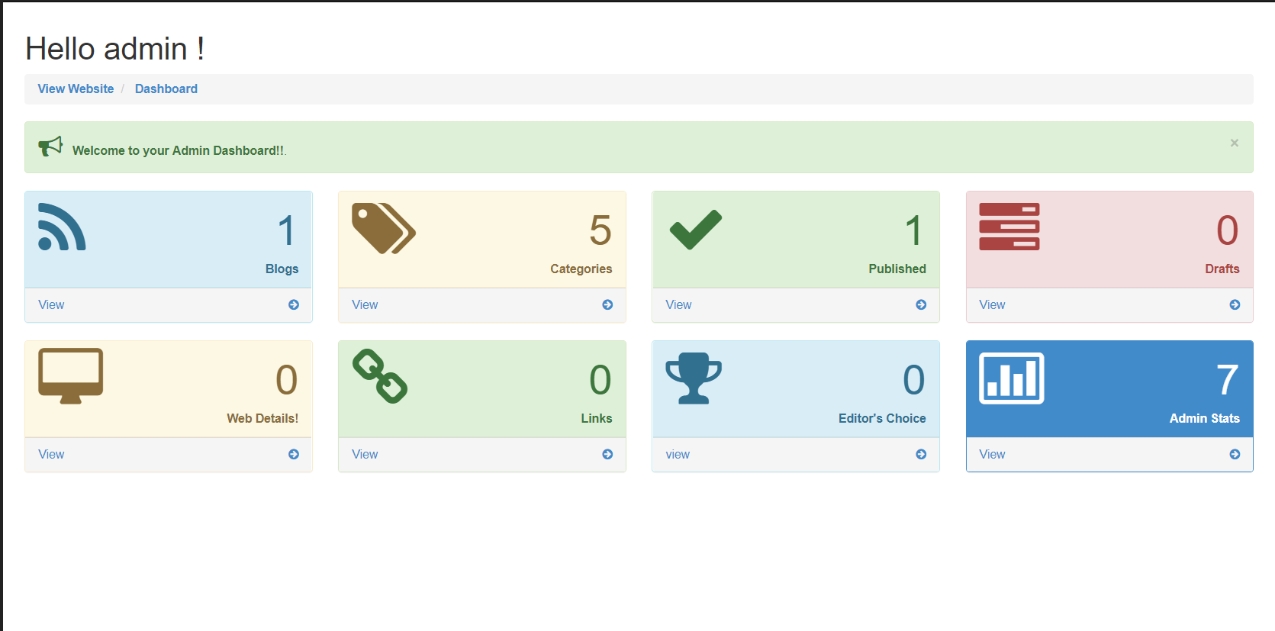

Figure 26:admin dashboard

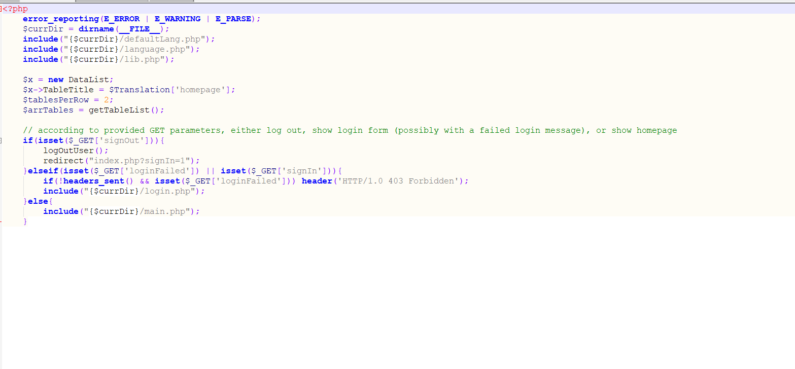

Figure 27:admin dashboard code

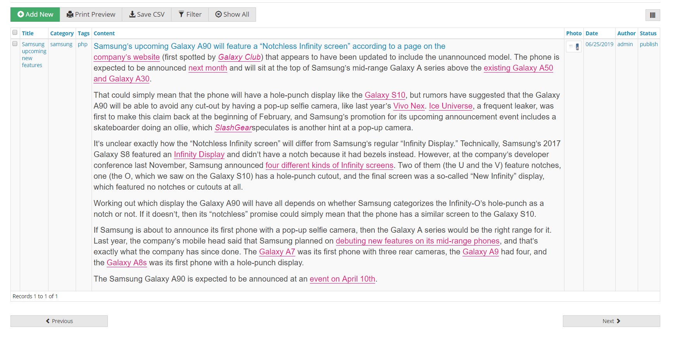

Figure 28:add category

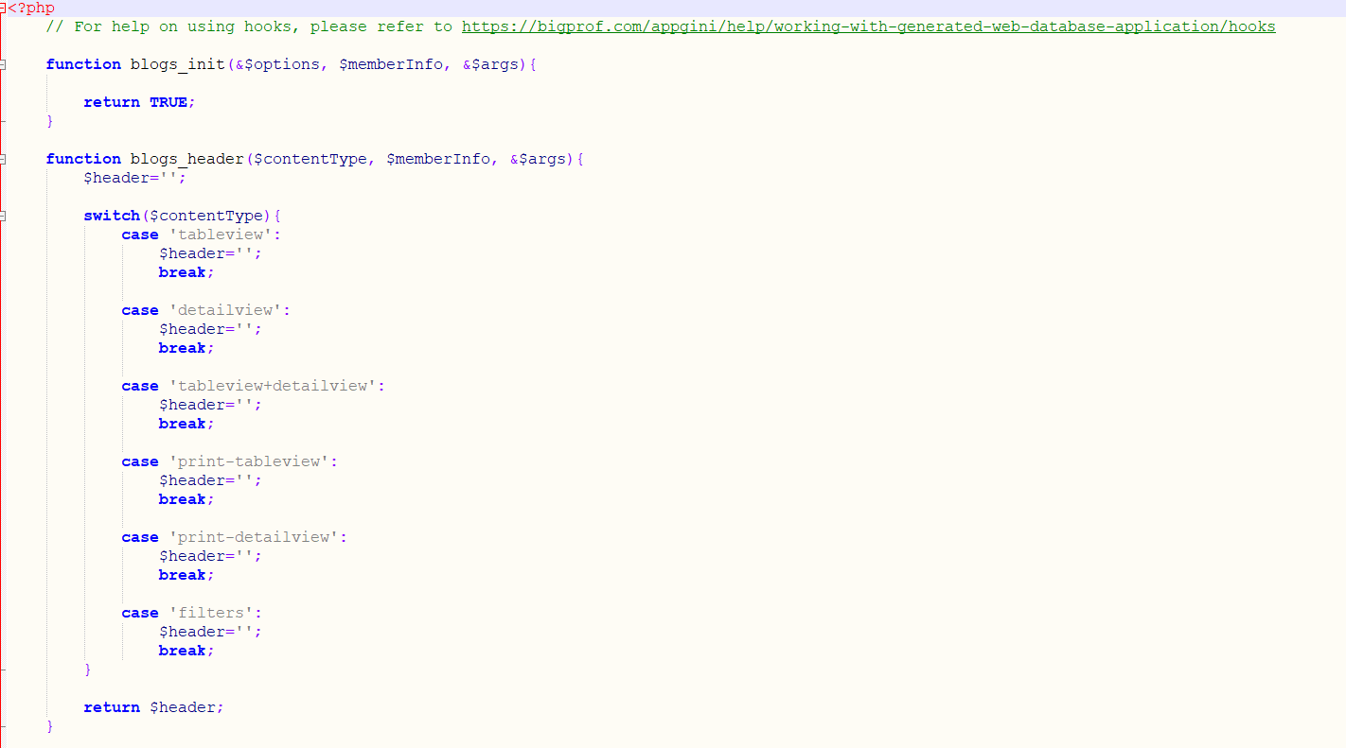

Figure 29:table view

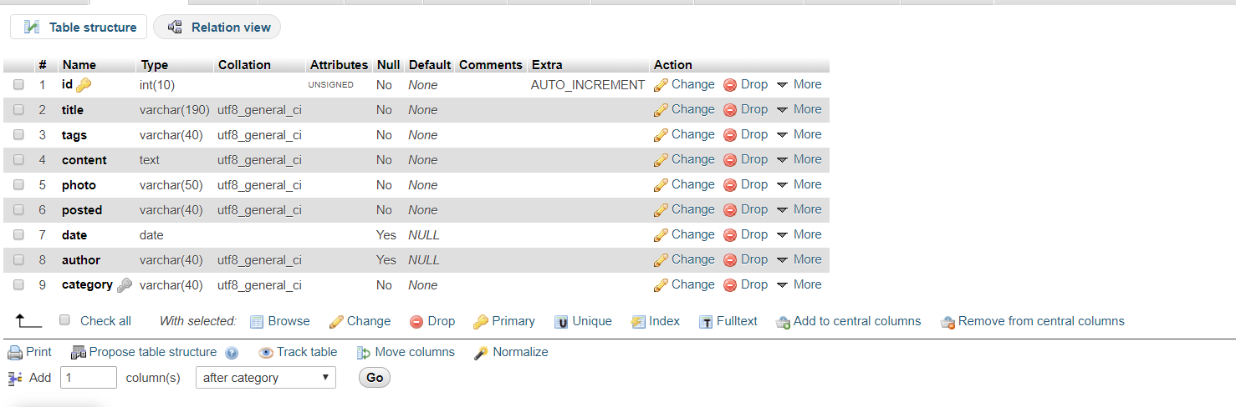

Figure 30:content database

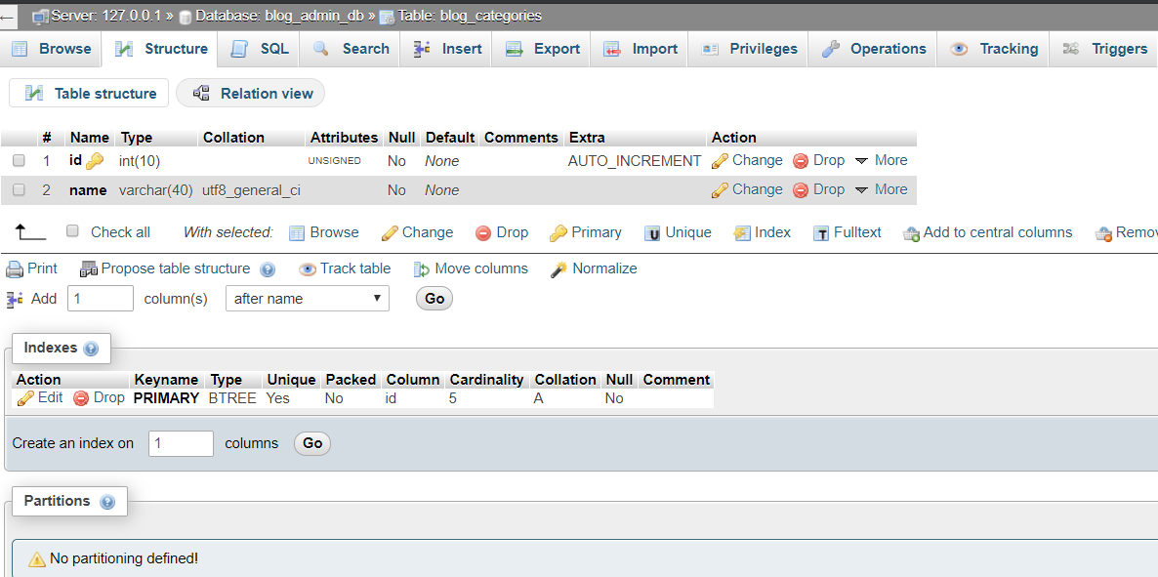

Figure 31:blog category

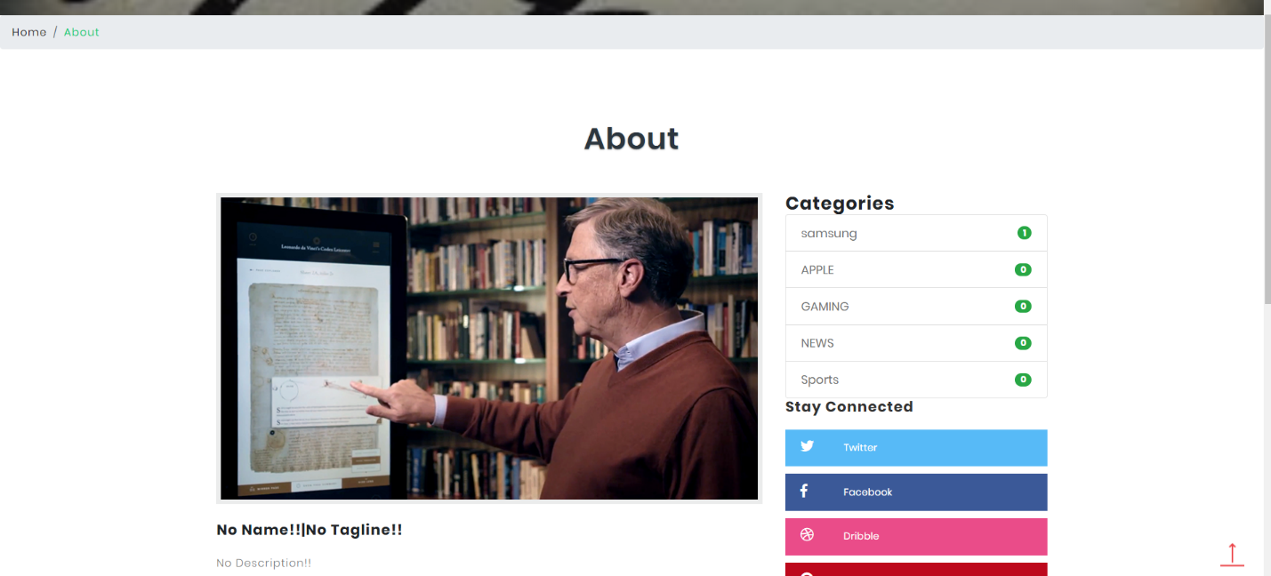

Figure 32:about homepage

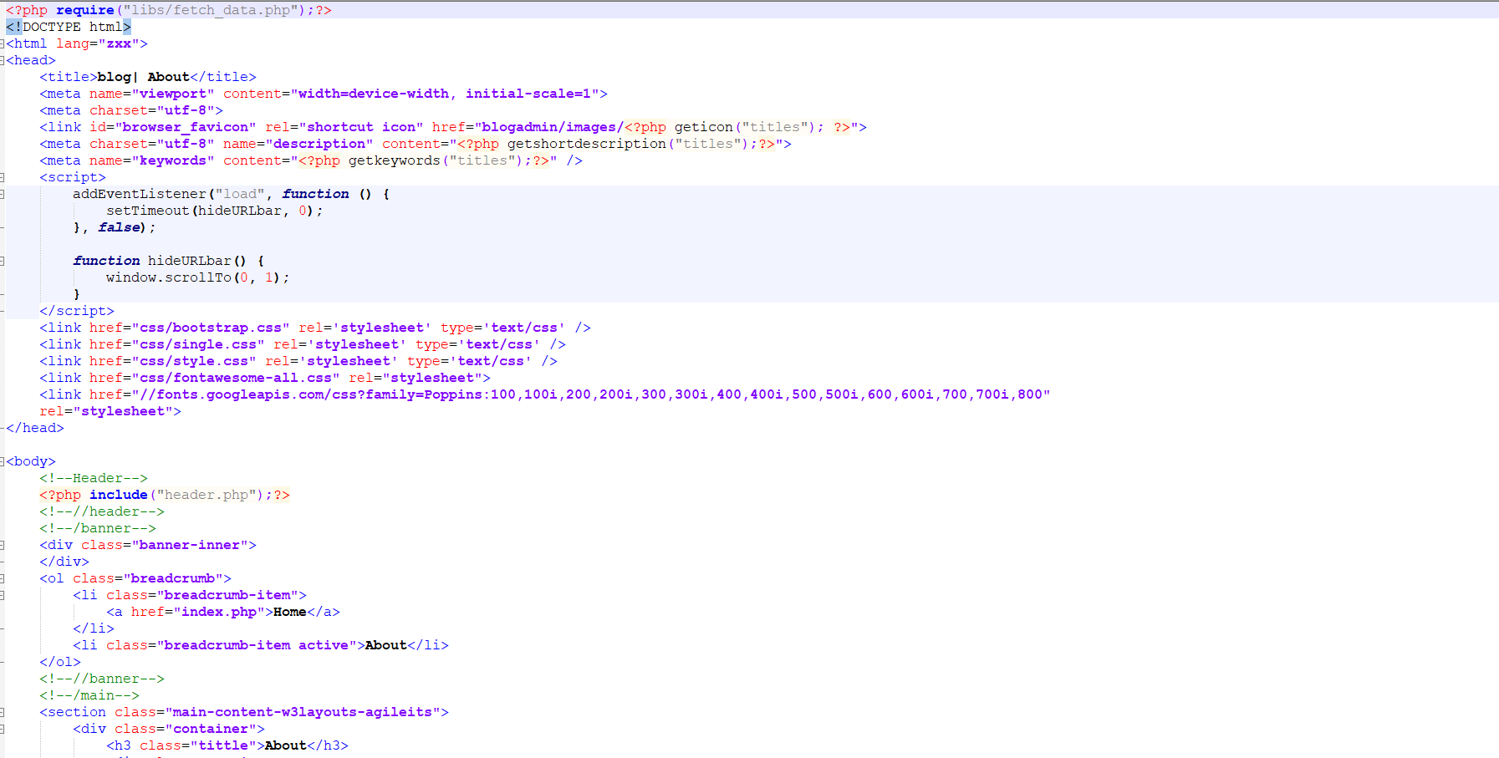

Figure 33:about home page code

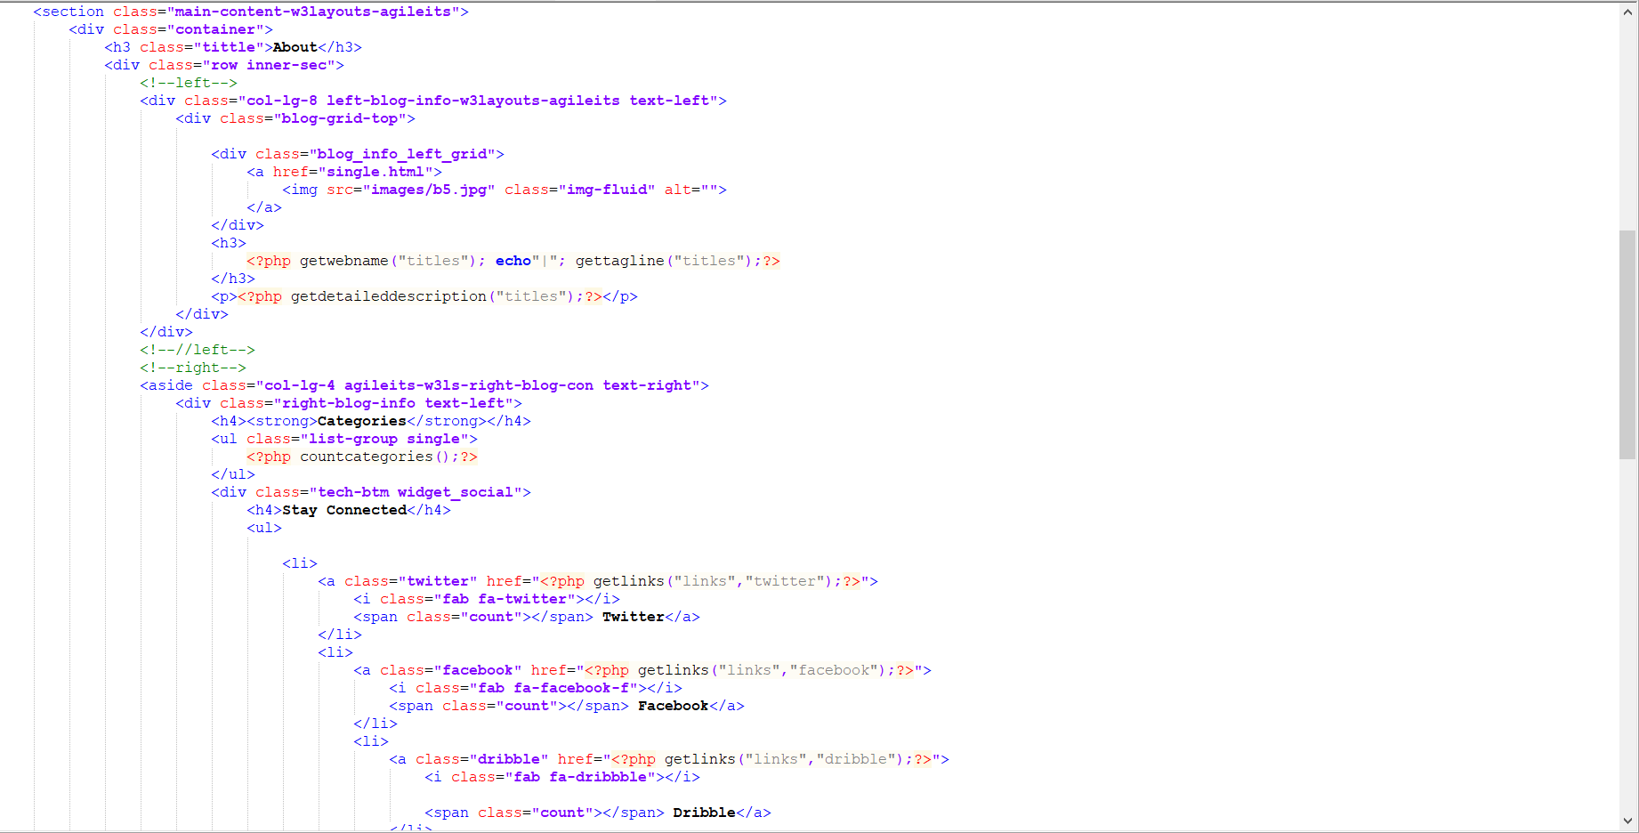

Figure 34:about homepage code

Diagram19:about homepage code

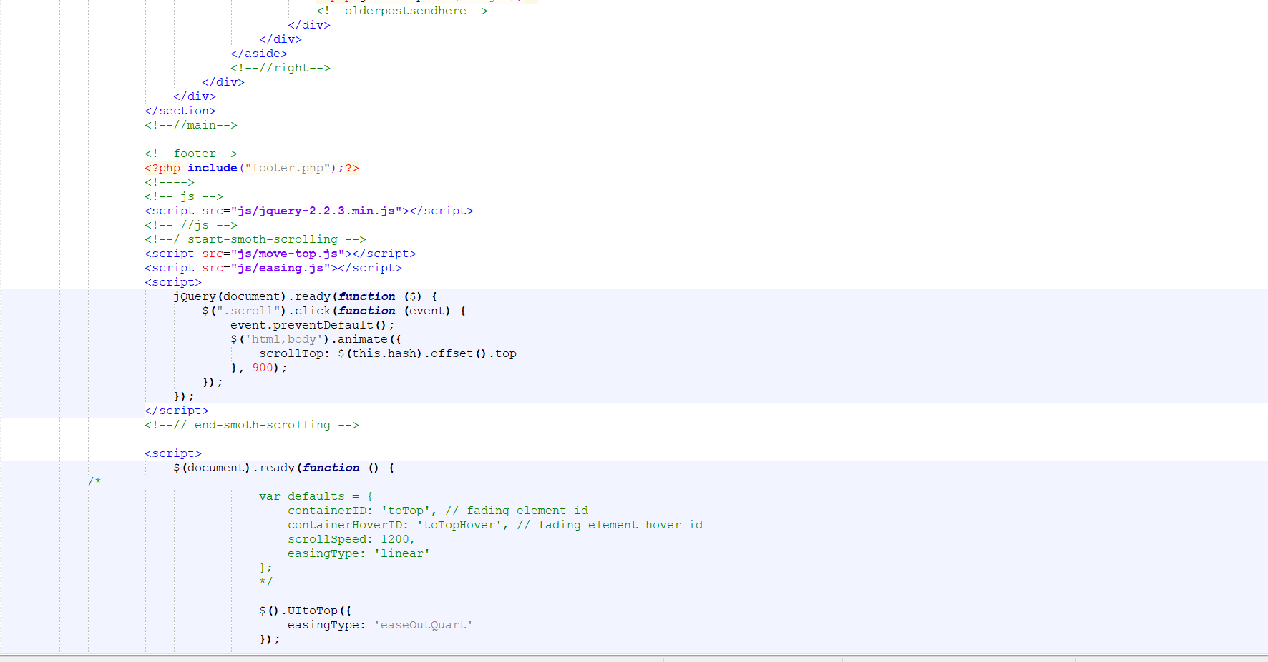

Figure 35:about homepage code

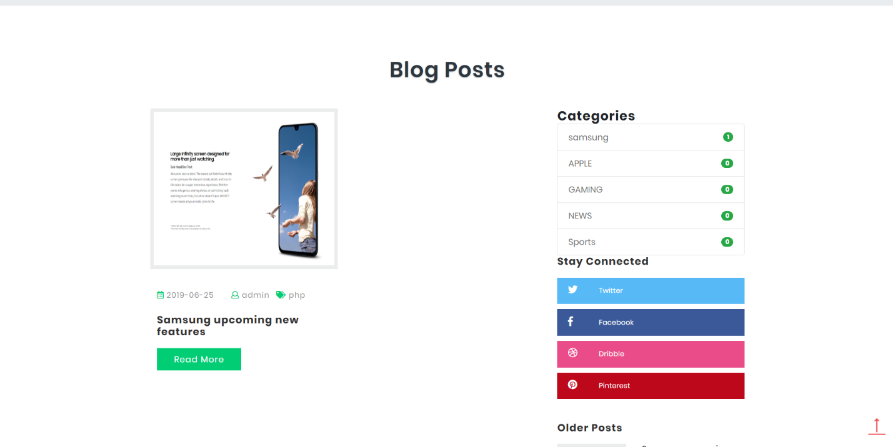

Figure 36:blog post homepage

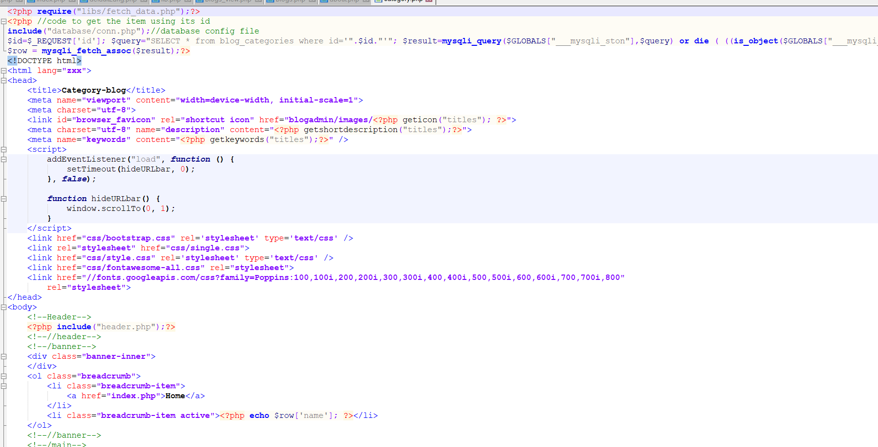

Figure 37:blog post homepage code

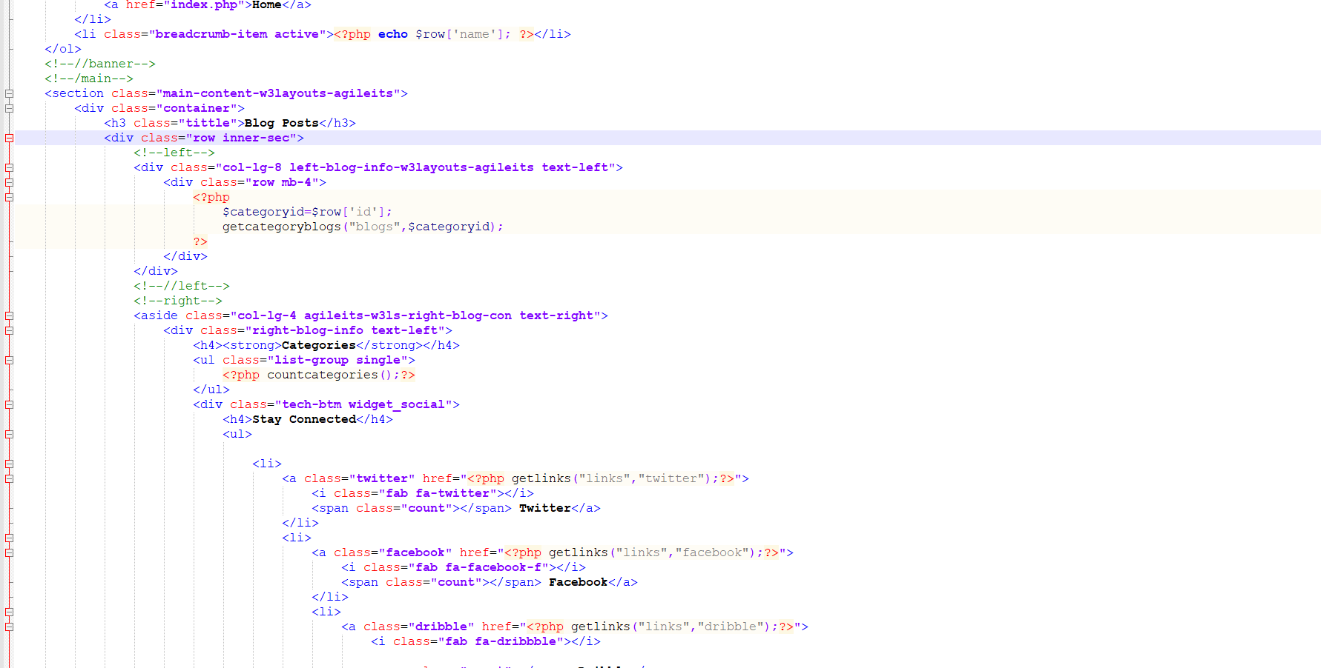

Figure 38:blog post homepage code

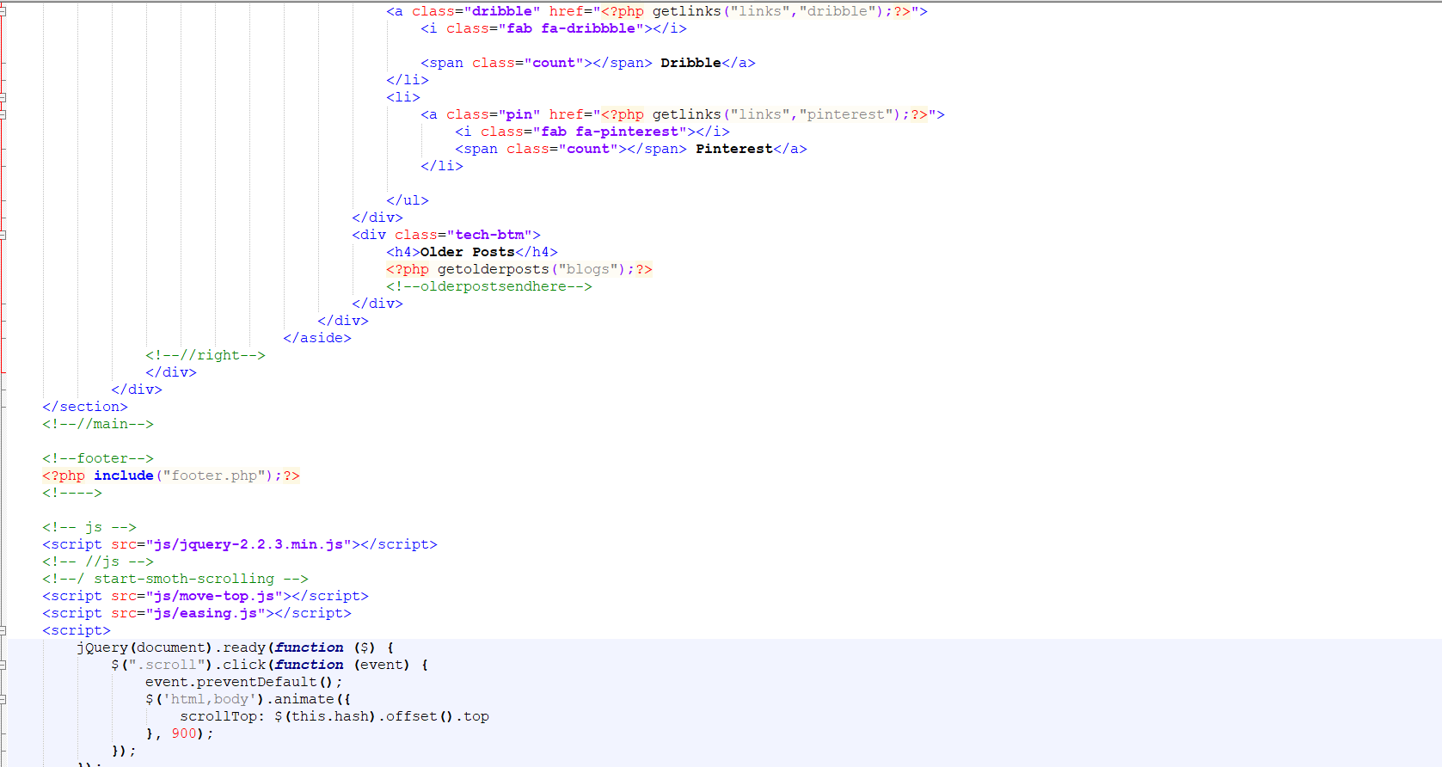

Figure 39:blog post homepage code

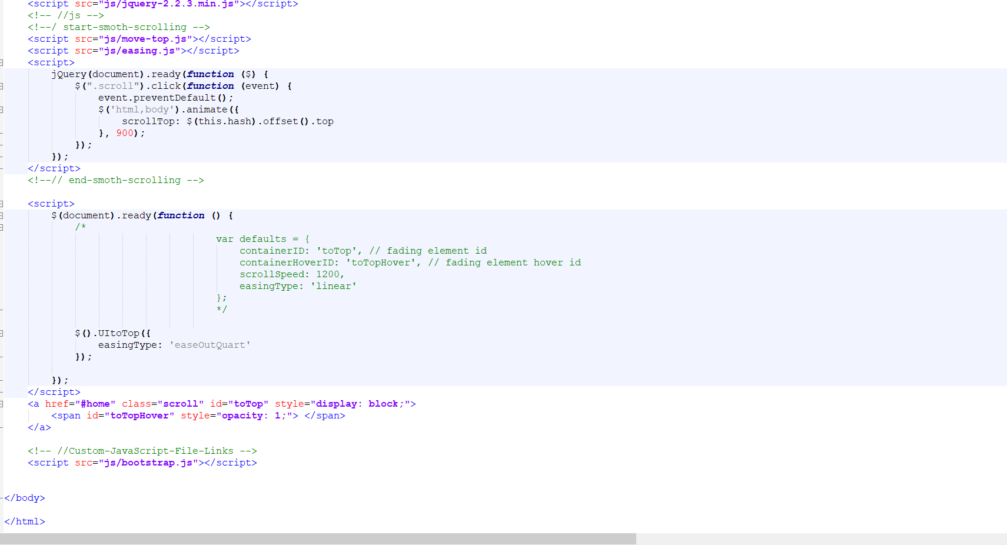

Figure 40:blog post homepage code

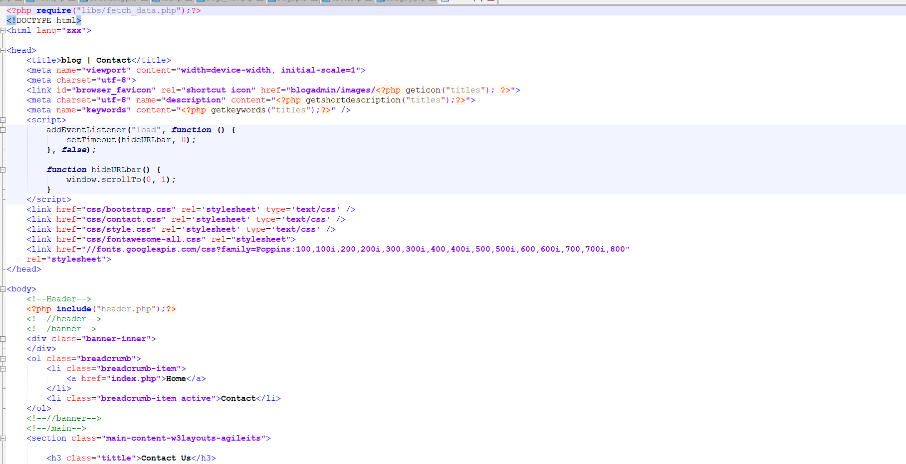

Figure 41:blog post homepage code

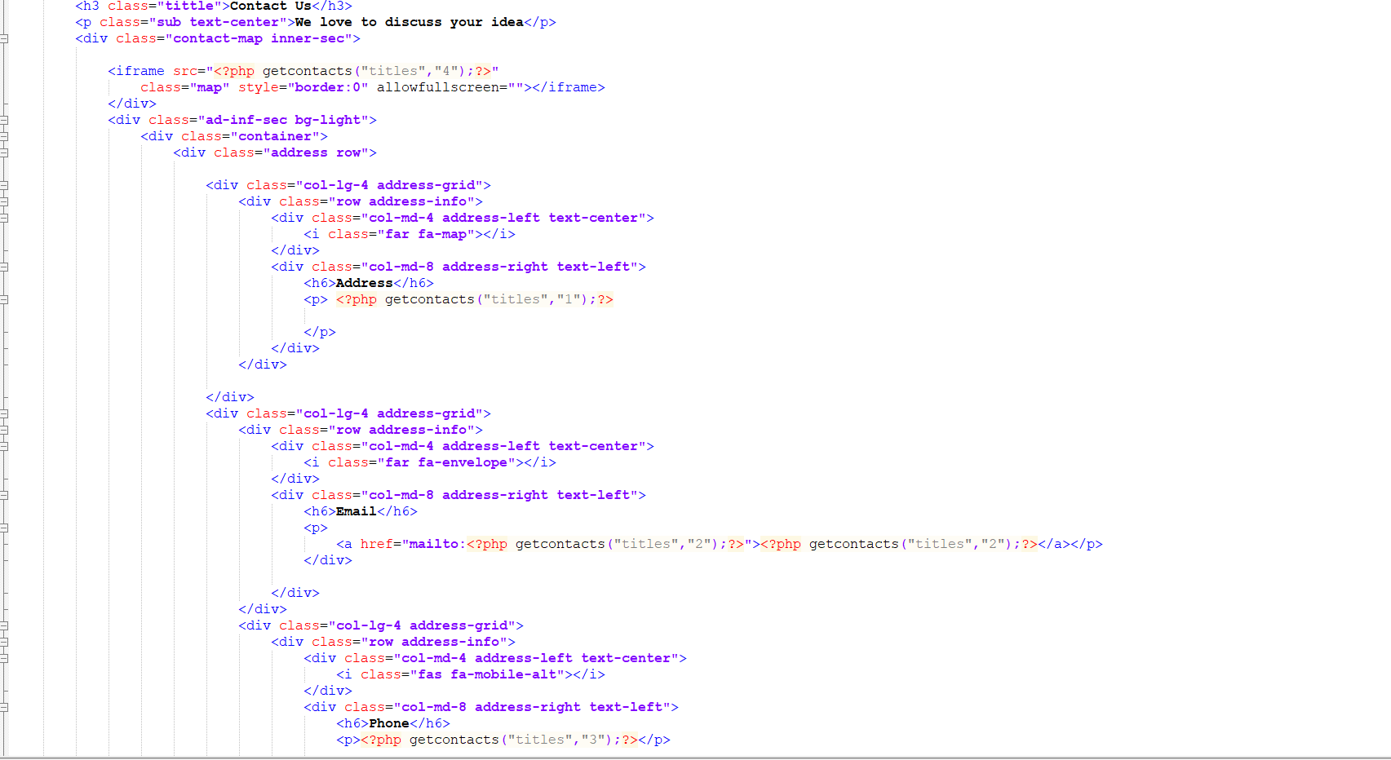

Figure 42:blog post homepage code

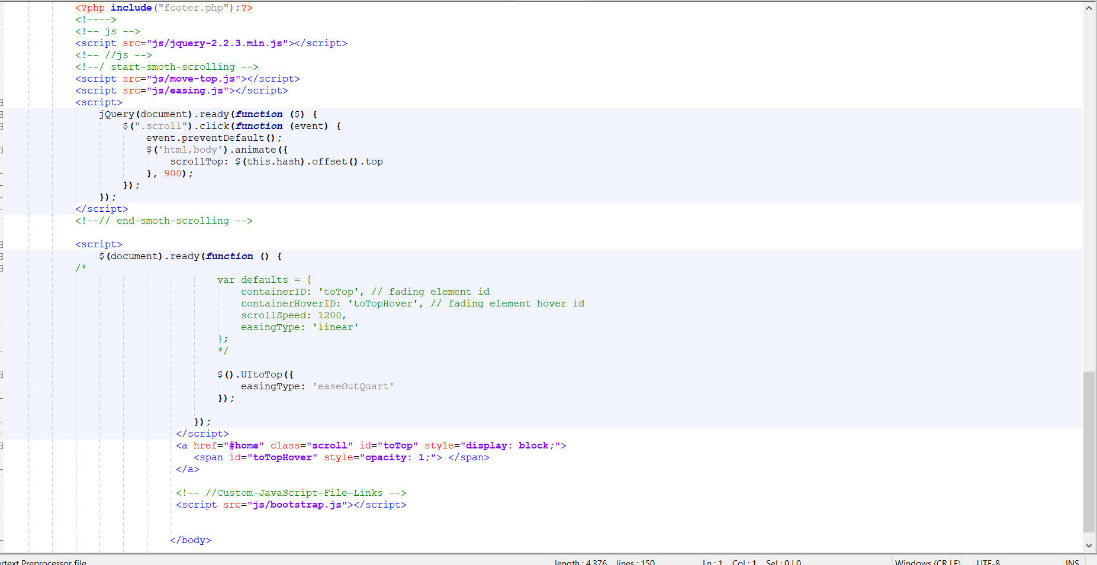

Figure 43:blog post homepage code

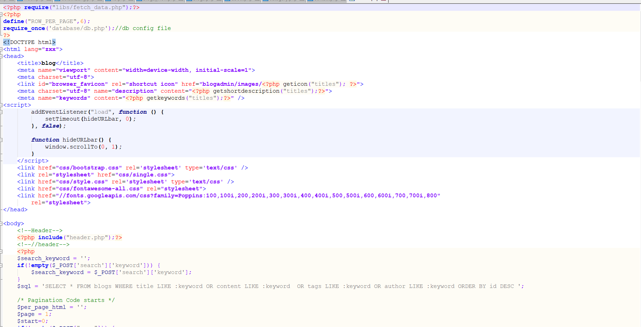

Figure 44:blog post homepage code

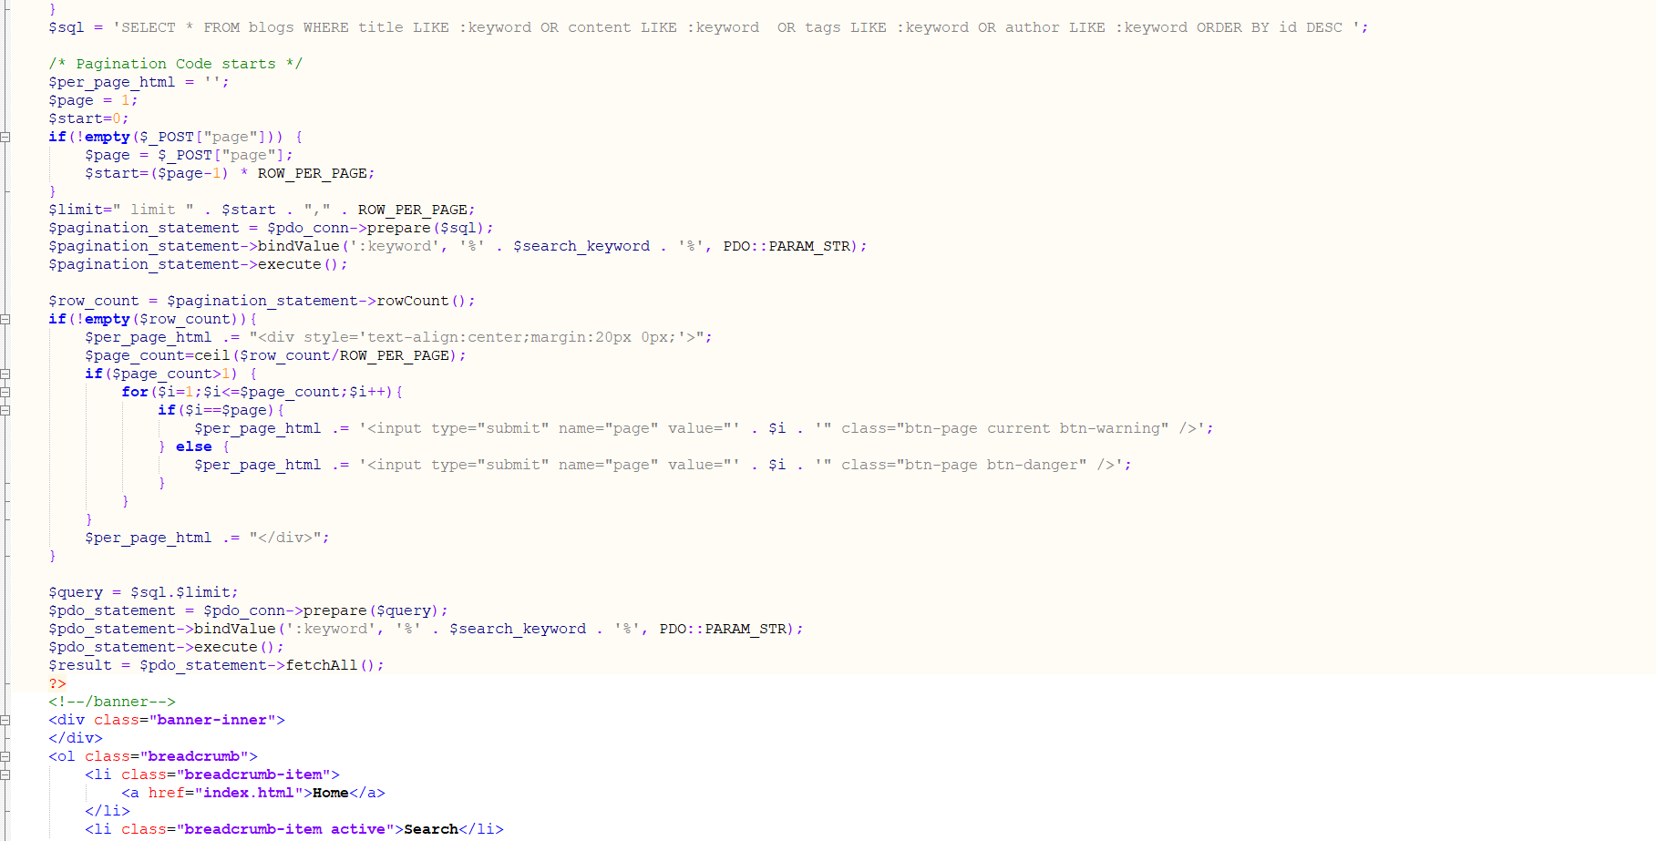

Figure 45:blog post homepage code

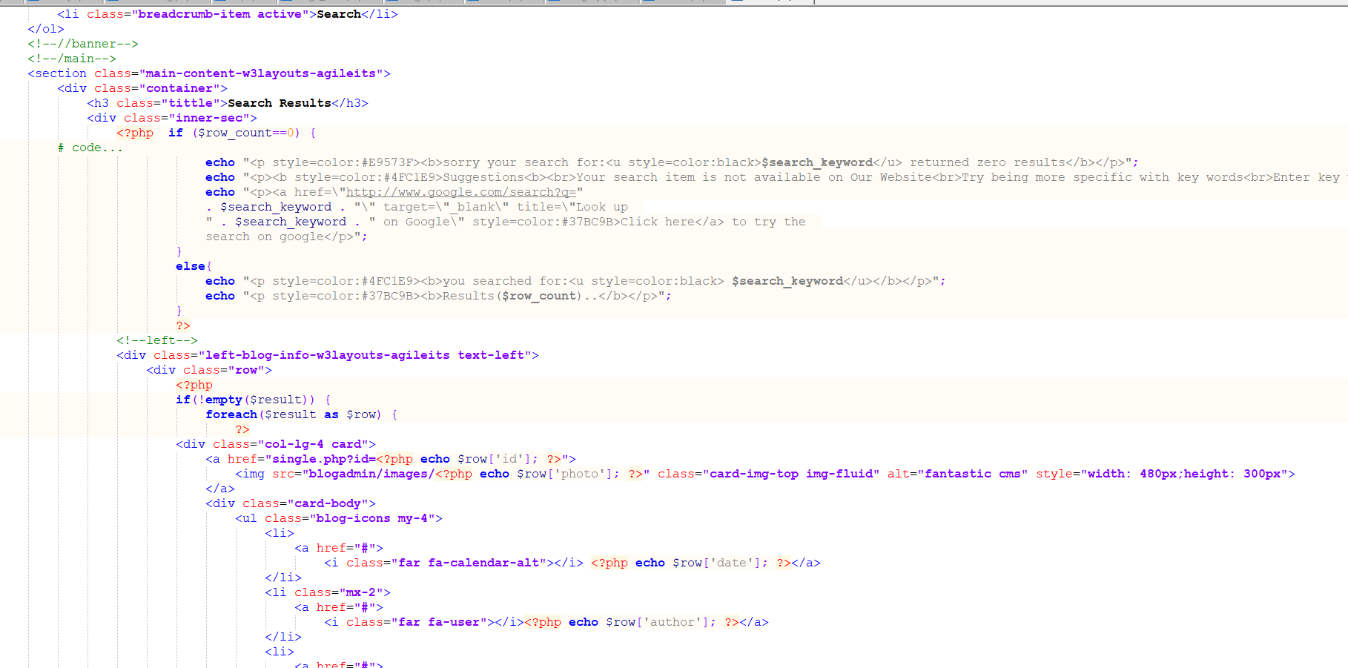

Figure 46:contact code

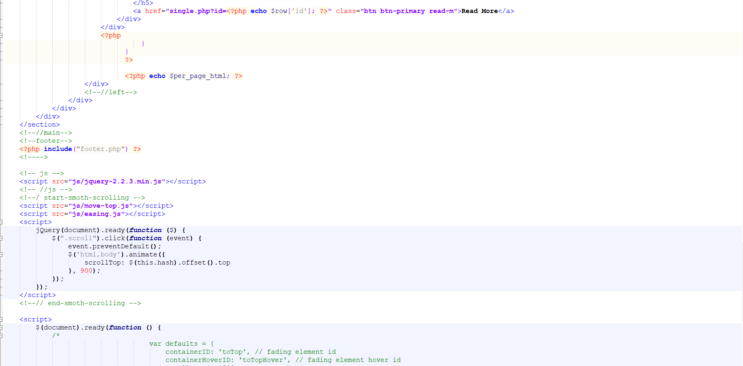

Figure 47;contact code

# 5 Testing:

5.1 Blackbox testing: It is a behavioral testing. This testing checks the design, implementation and structure of the project. Black box testing can be functional or non-functional but mainly it uses functional.

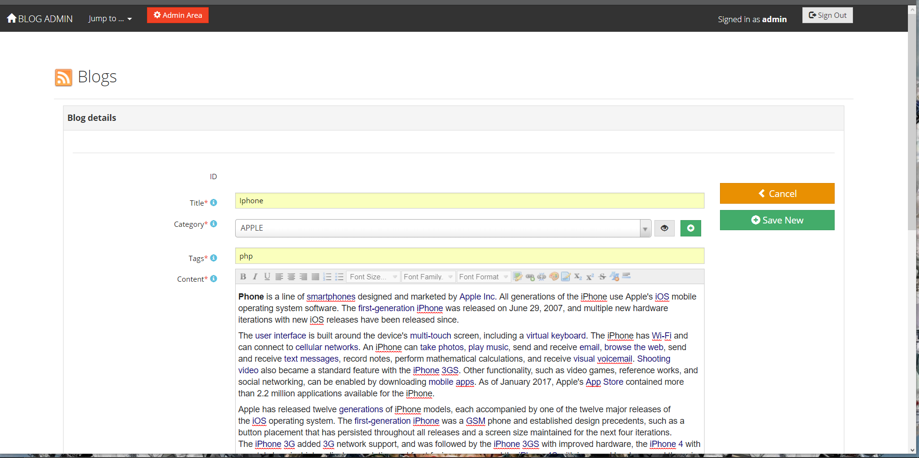

Figure 48:blog insert

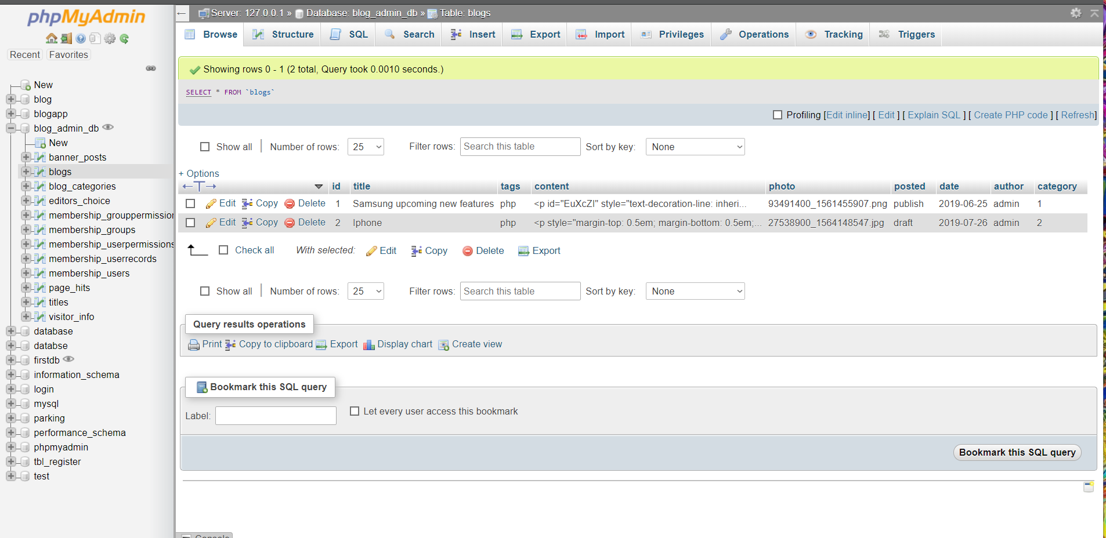

Figure 49:blog database

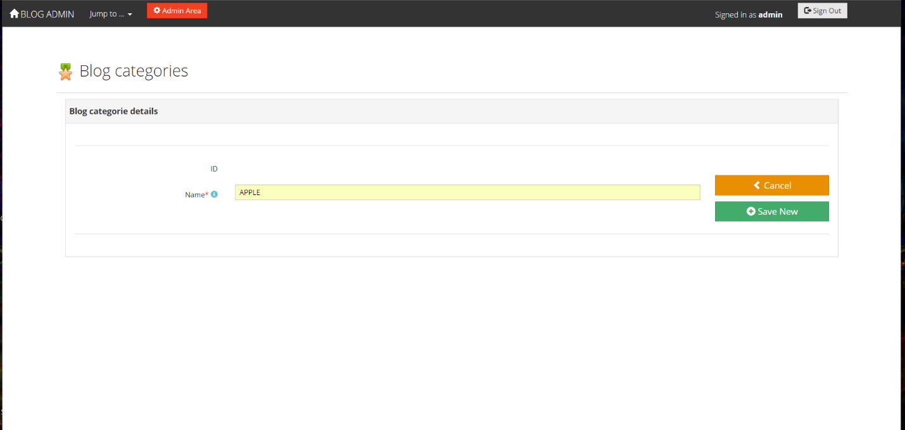

Figure 50:blog category

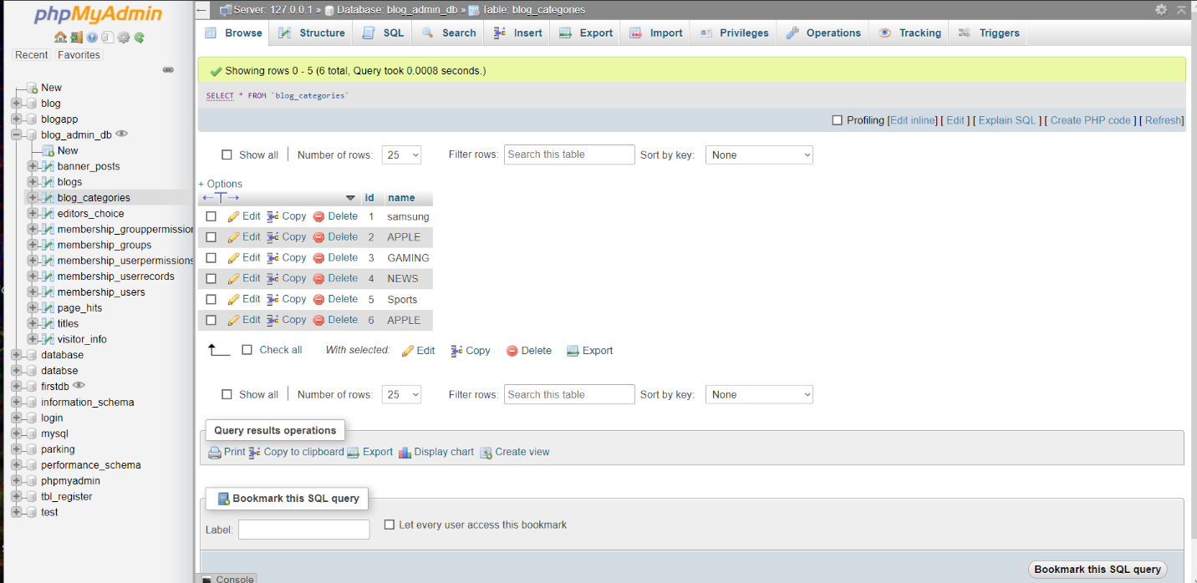

Figure 51:blog category database

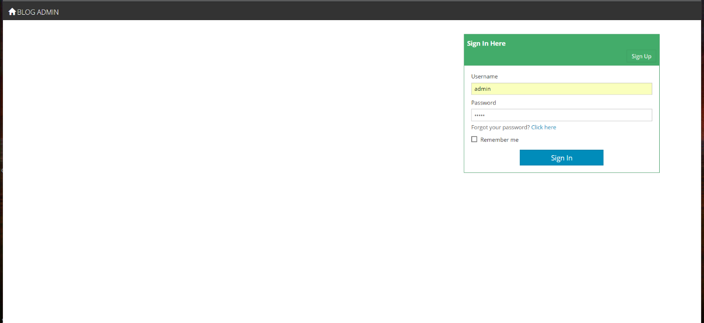

Figure 52:ogin form

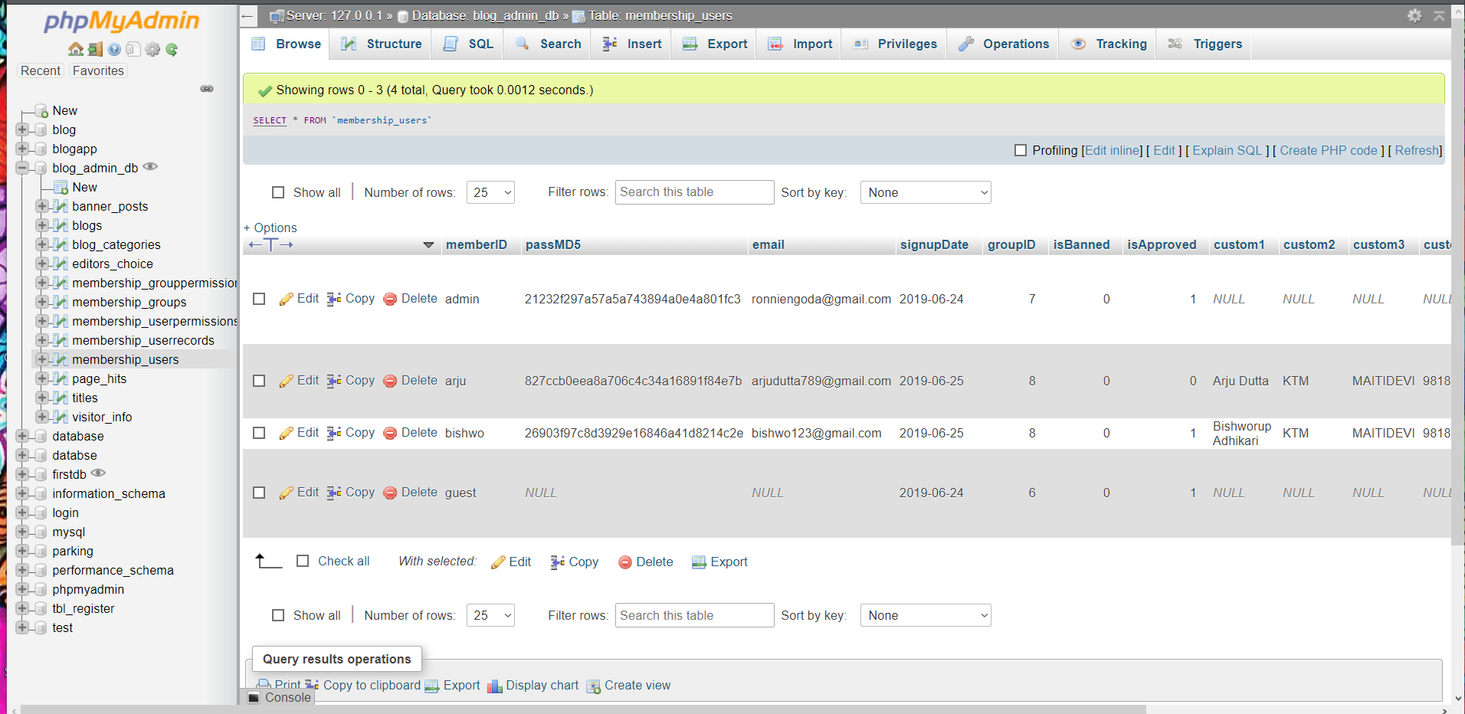

Figure 53:login form database

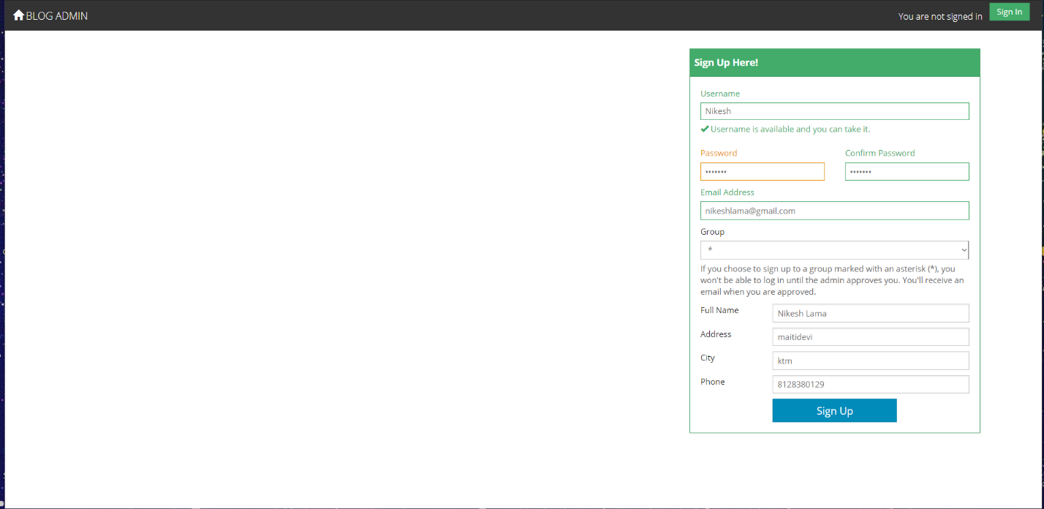

Figure 54:admin register form

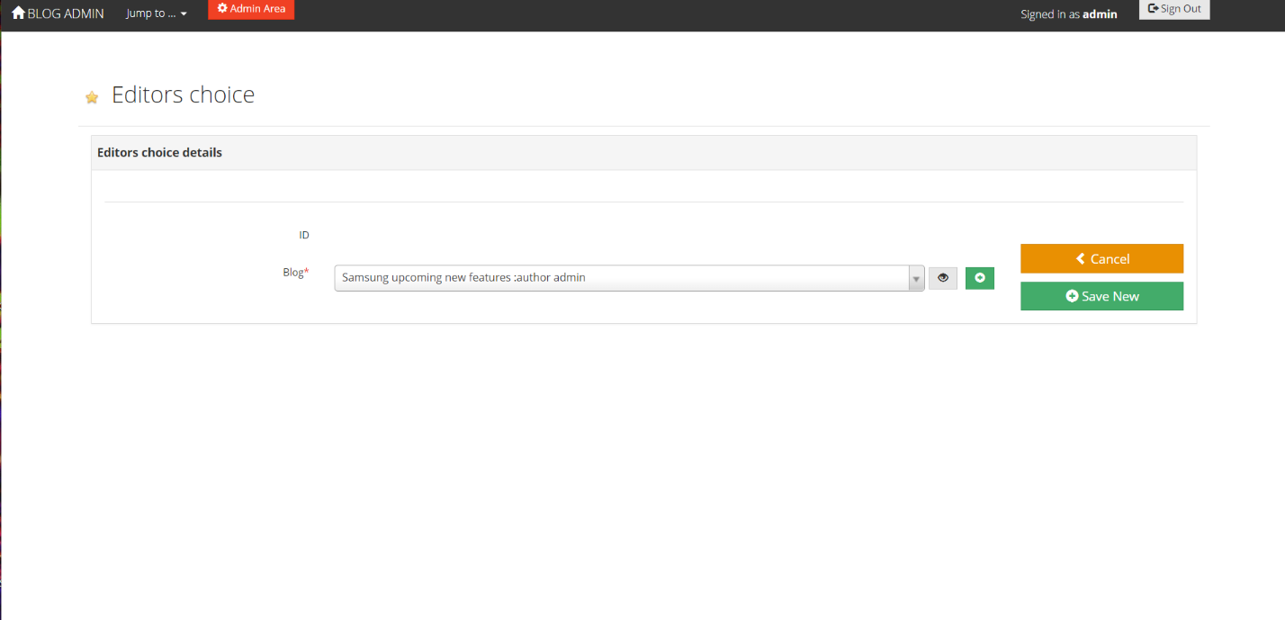

Figure 55:editor choice details

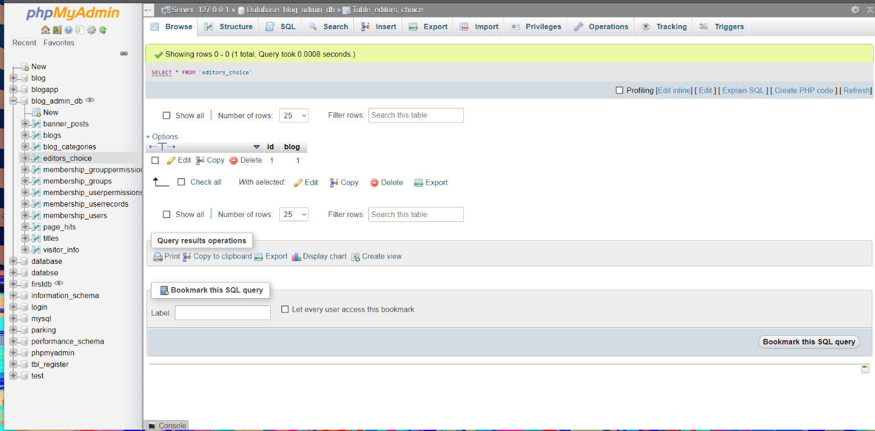

Figure 56:editor choice details database

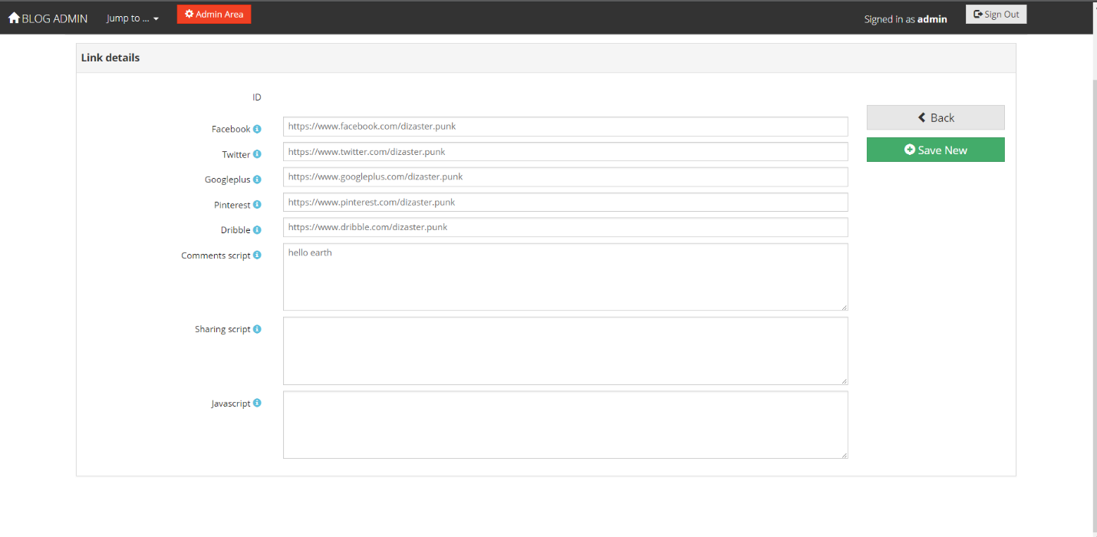

Figure 57:link details

## 5.2 Unit testing:

It is a level of the software test where many components and individual units are being tested. It is the tiniest testable phase of software. It has only single unit and has only one or less than one inputs. A unit testing may be an single program or procedure in procedural programming.

# 6 Topic

Blog application is my title for this computing project. It is a web-based application made by using core php, MySQL, java script, j query and others. This computing project developed in water fall model. It is offline based app with different local database. It is used for maintaining the information provided by user to admins.

## 6.1 Introduction of project:

Blog application is web-based app where user can upload their information or business details of there company. It helps them to keep their information private within user and admin. Admin are only allowed to delete or reupload the information provided by the user. It helps to update, create and delete of information provided by the user to admin. This application helps user to maintain their company financial information.

## 6.2 Risk management:

The way of analyzing the problem that may impact in the project can be known as risk.

There can be many risk while creating this project likewise personal information leakage of the user.

The following are the ways to manage the risk management are:

* Avoidance
* Reduction
* Sharing
* Retention

**Impact = Likelihood * Consequence**

Risk Likelihood values are shown as follows

|  |  |
| --- | --- |
| Likelihood | Value |
| Low | 1 |
| Medium | 2 |
| High | 3 |

* Risk Consequence values are shown below

|  |  |
| --- | --- |
| Consequence | Value |
| Very low | 1+ |
| Low | 1 |
| Medium | 2 |
| High | 3 |
| Very High | 4 |

Risk Consequence values are shown below

|  |  |  |  |  |  |
| --- | --- | --- | --- | --- | --- |
| S. No | Risks | Likelihood | Consequences | Impact | Solution |
| 1 | Poor user interface | 3 | 3 | 4 | User interface should be designed properly. |
| 2 | Data lost | 1 | 3 | 4 | Keep backup of all data |
| 3 | unsatisfied | 2 | 2 | 2 | Meet all the requirement and use easy interface |
| 4 | Server Failure | 2 | 1 | 2 | Server should be maintained in time to time |

## 6.3 Configuration management:

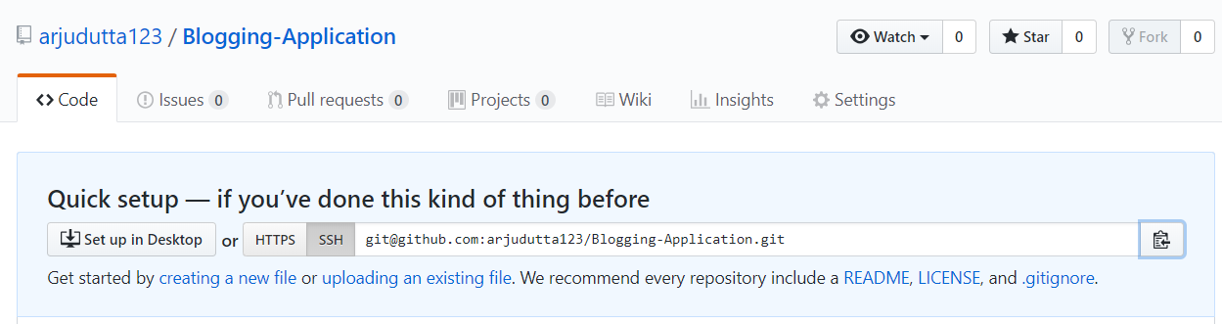

Figure 58:configuration management

<https://github.com/arjudutta123/Blogging-Application>

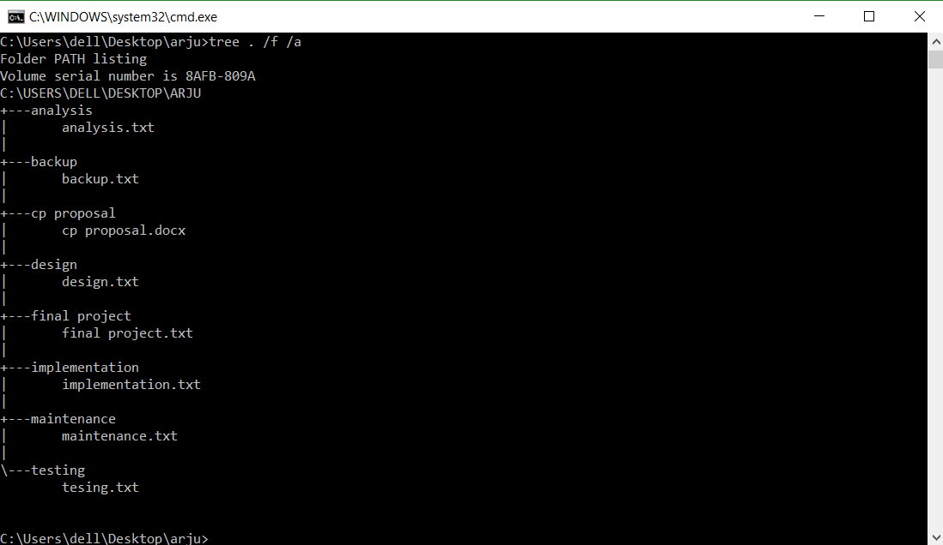

Figure 59:tree

6.4 Scheduling: 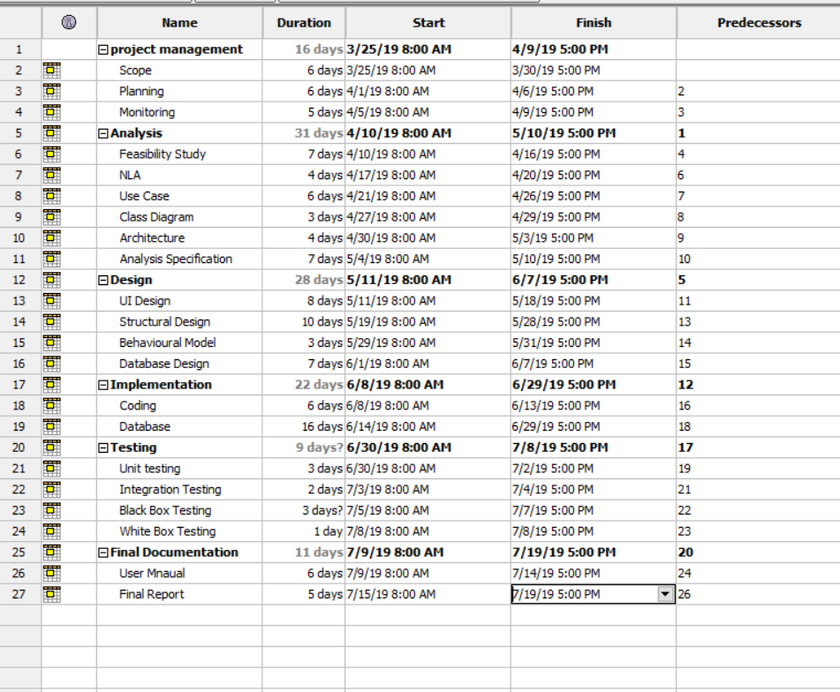

Figure 60:day estimated

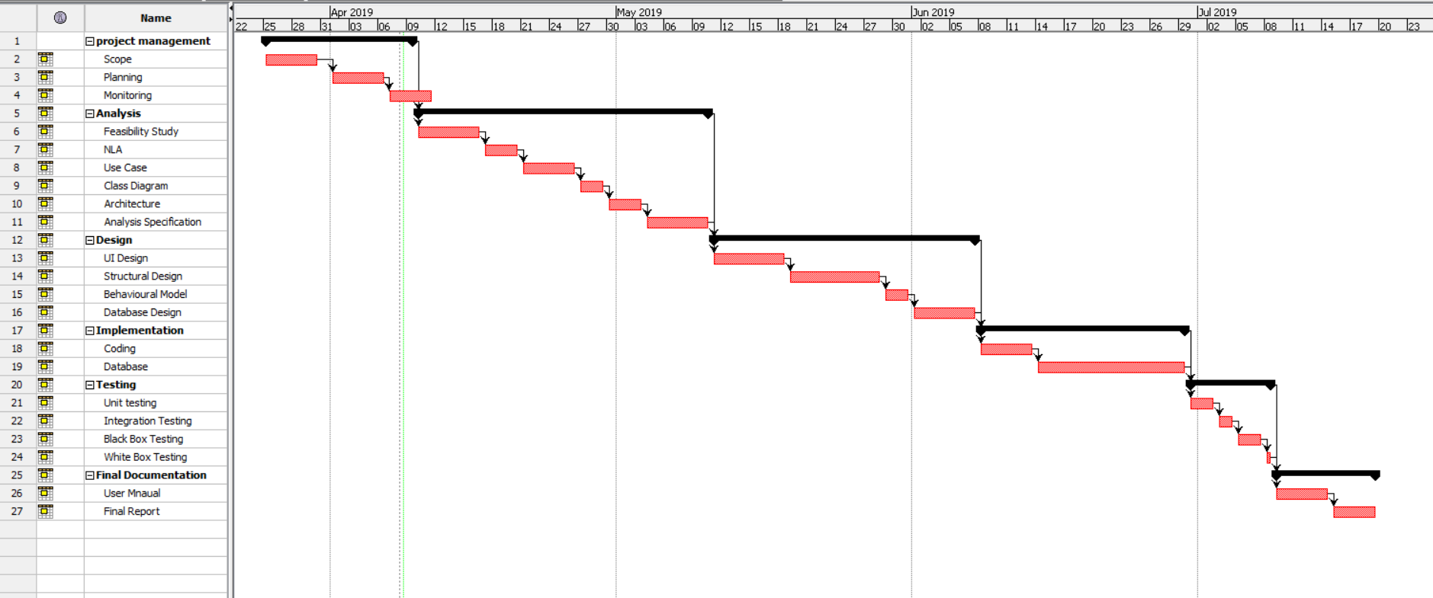

Figure 61:Gannt chart

## 6.5 Future work:

I will make this application in overall operating system likewise android, IOS, windows etc. So, the user can easily access through this application. And I will also make this application online based where user and easily deal with solution. In the future I will make this application so that user can download this application from app stores. User can also follow and unfollow the categories of this application. They can like, unlike or comment the post. And even user can delete or can insert the post in this web based application.

## 6.6 User manual for admin

Guide1: register into the web application.

Guide 2: after registration login to the system to enter the dashboard

Guide 3: after entering the dashboard you can choose icon to create update delete the post

Guide 4: admin have to enter in the admin setting to change the password, edit post, delete post.

## 6.7 User manual for user

Guide 1: open the web application

Guide 2: view the latest application post

Guide 3: click on to the image to view its detail.

## 6.8 Limitation:

You can’t share wrong information in the media. In case, if you did so you will be reported in the cybercrime. And remaining point are listed below:

* This application is not online based
* User cannot upload the post
* User cannot delete the post
* User cannot insert the post
* Unauthorized post cannot be upload in this application
* It has got limited amount of features

# 7 Appendix:



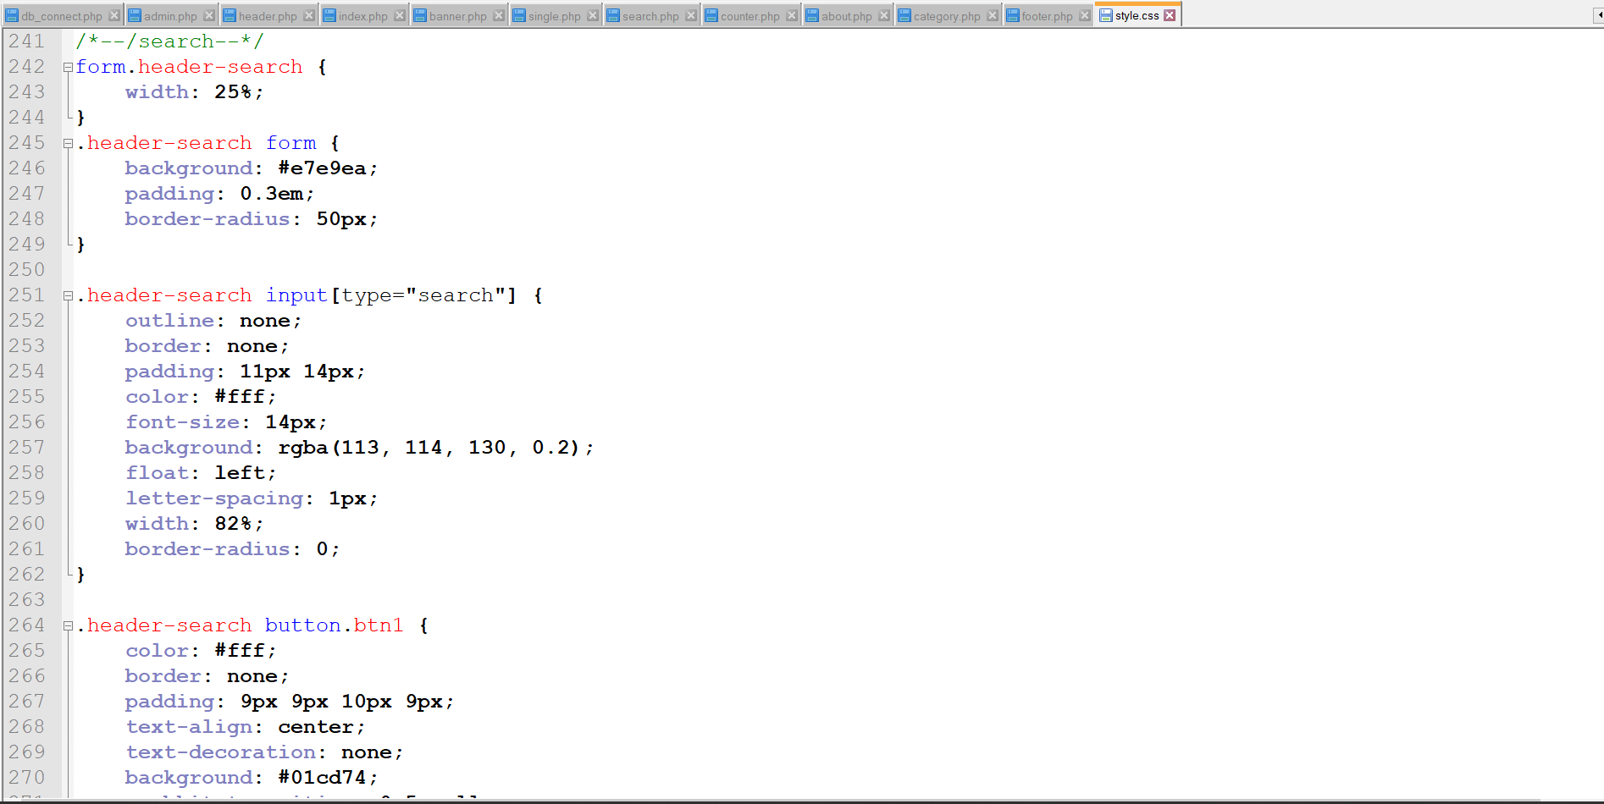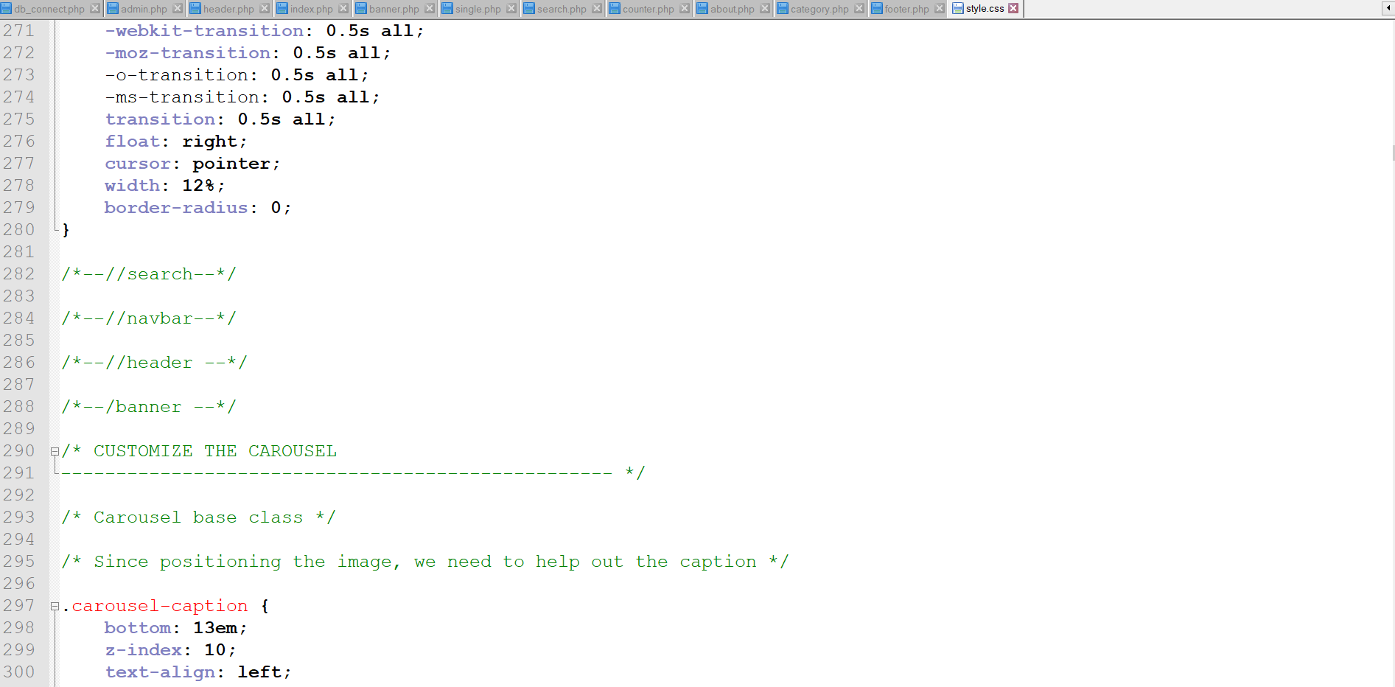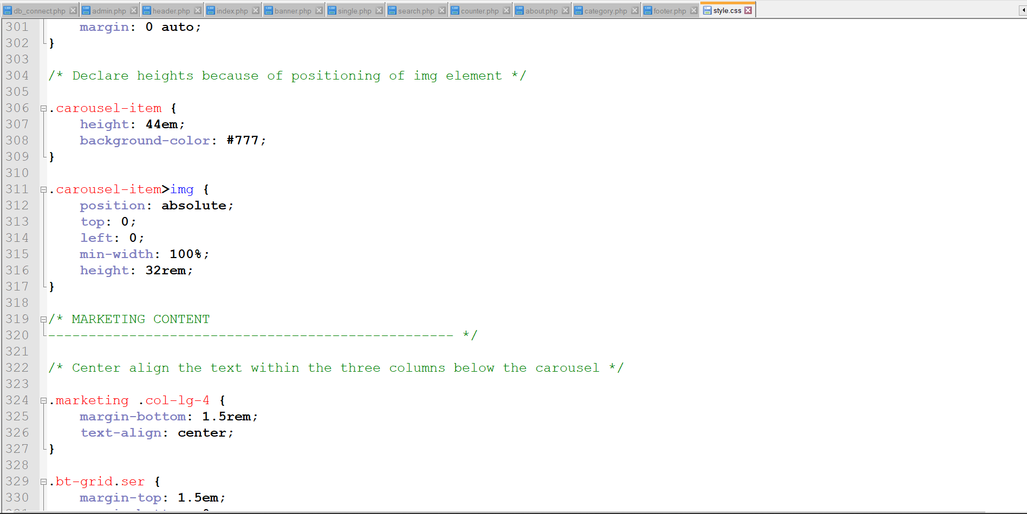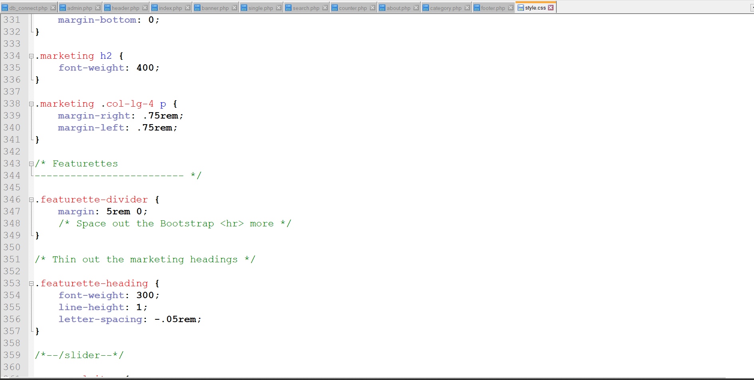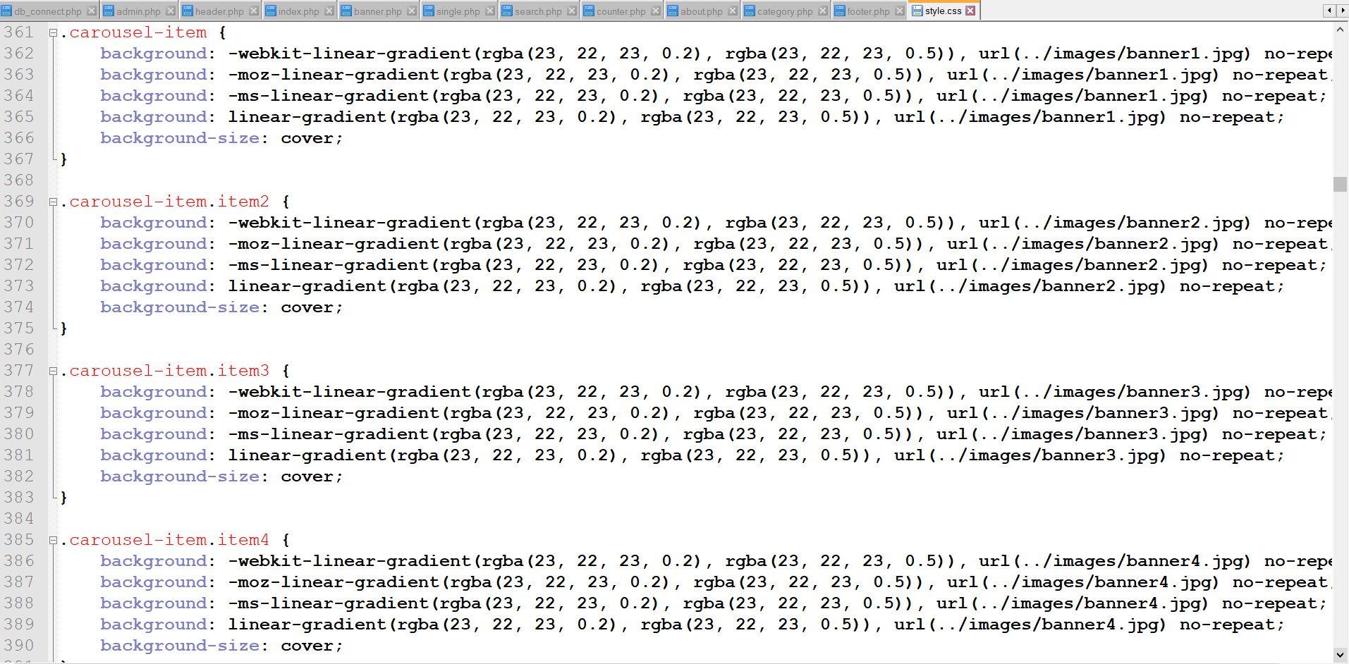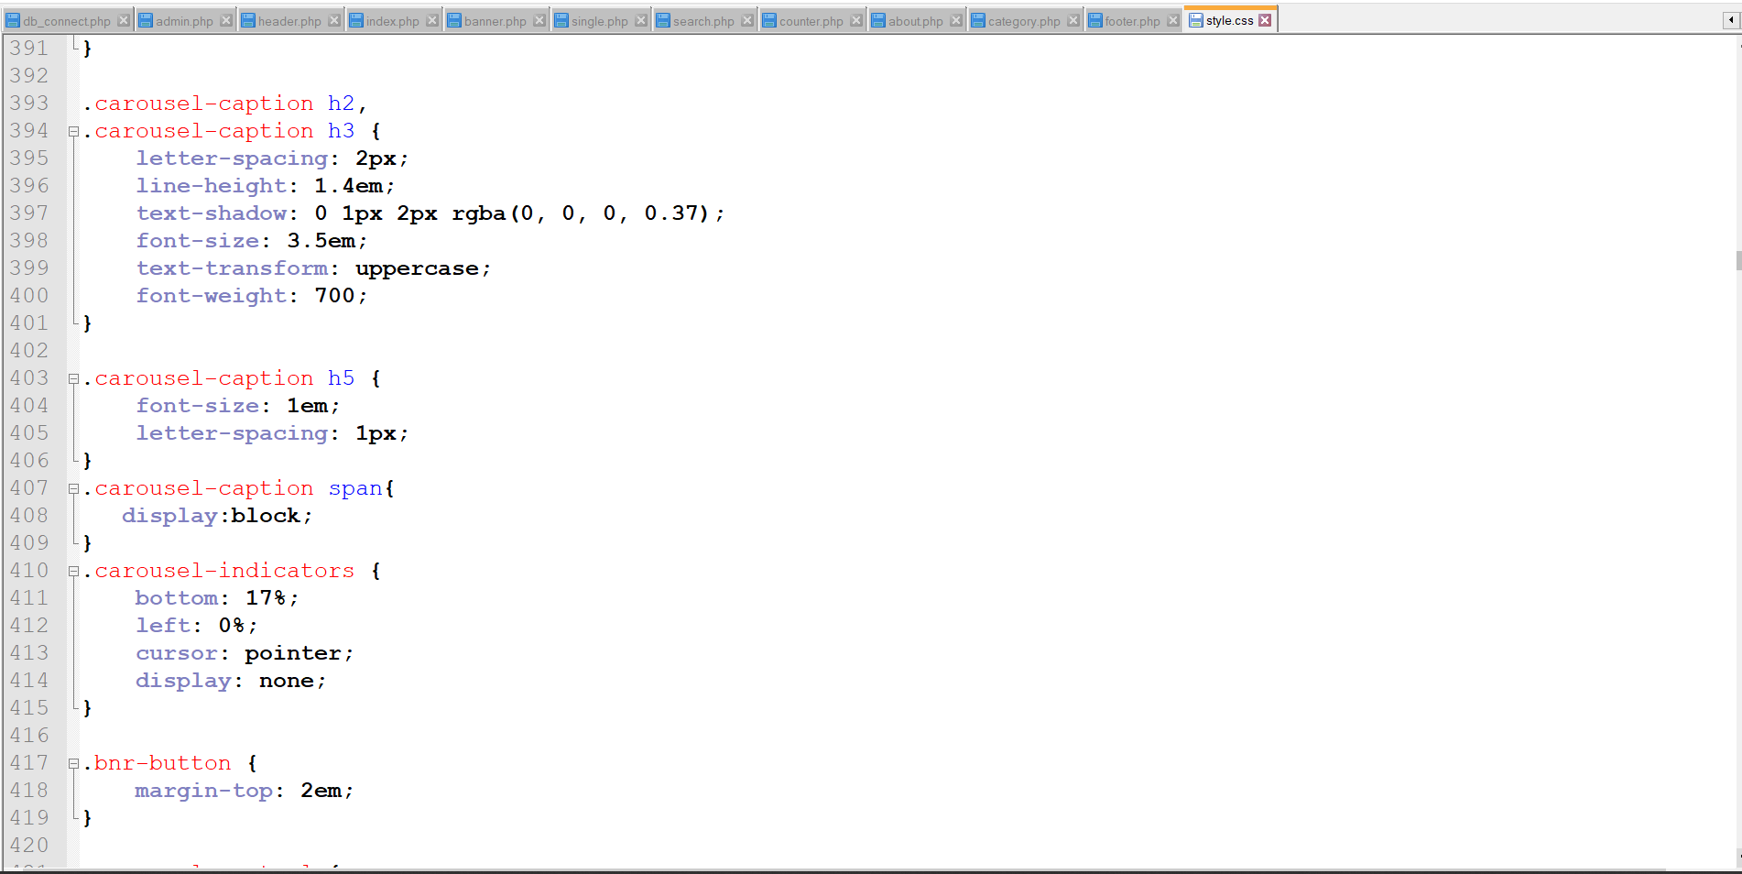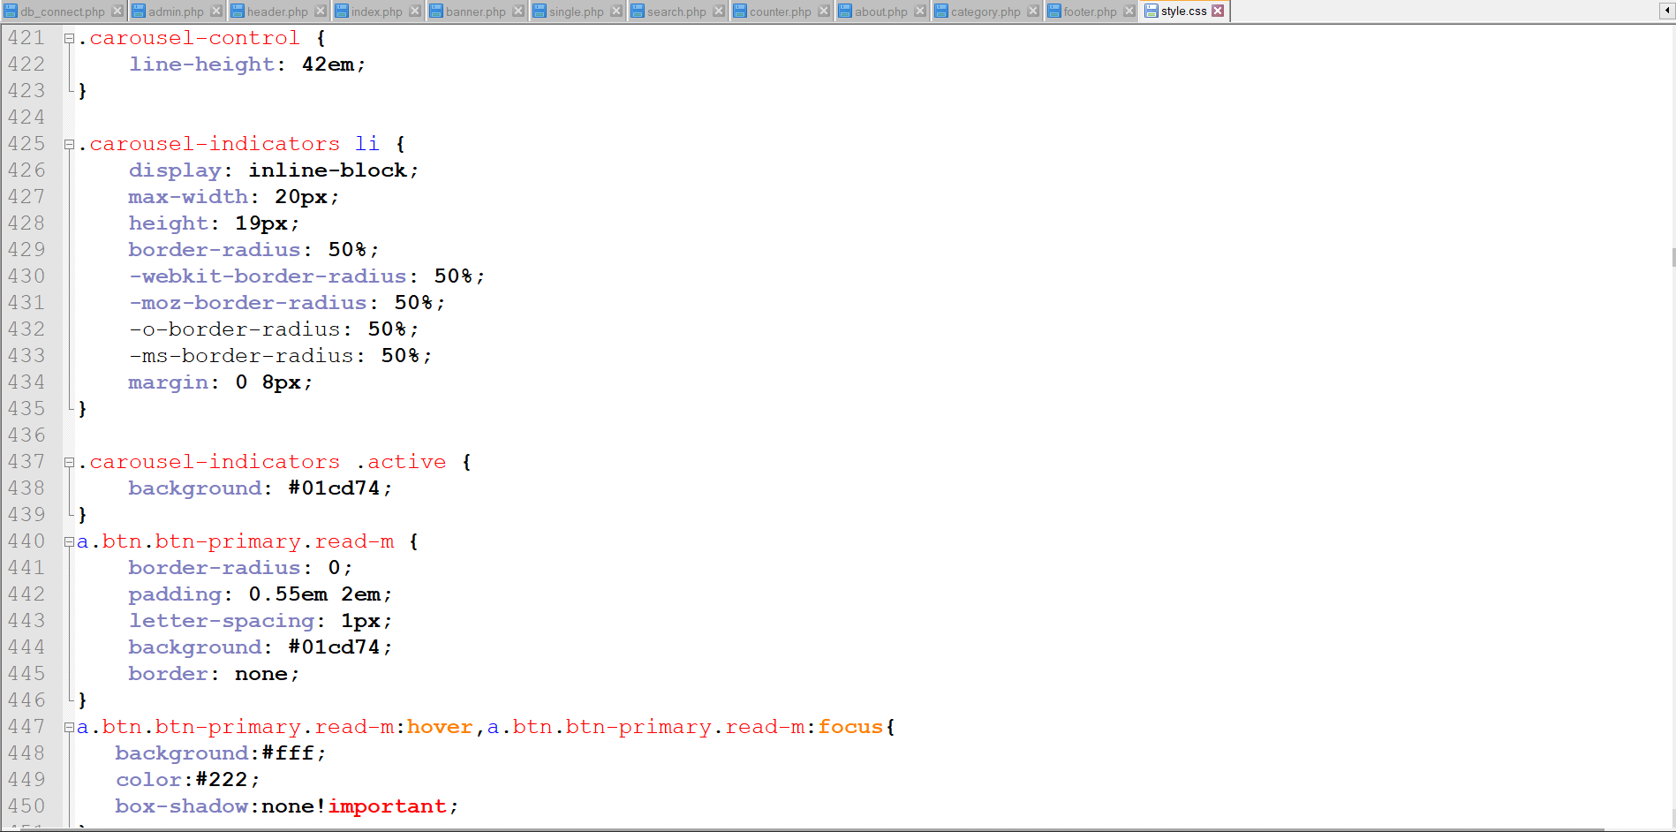



# Conclusion

This blogging application is to provide the information to the world. As I had made, web application, I have use object-oriented programming in this web application. In this web application customer can view the latest information. Admin will post different category of information. I have given priority of the Moscow prioritization on this project. In have use core php for this blogging application. This is not online based application. User can only view the latest information. All the information are uploaded by admin.

# References

References

Anon., 2017. W3Schools Online Web Tutorials. [Online]

Available at: https://www.w3schools.com/

[Accessed 11 june 2019].

Anon., 2019. Stack Overflow - Where Developers Learn, Share, & Build Careers. [Online]

Available at: https://stackoverflow.com/questions

[Accessed 9 may 2019].